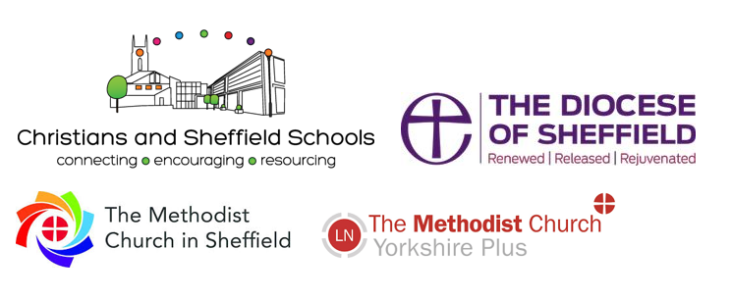

School Chaplaincy and School Ministry Training Course Reviews

“Thank you – I am so grateful for your shared wisdom.”
“Well thought through.”
“I’ve attended a lot of training in my secular job, but this was the best training I’ve ever done”
“Lots of great input. Inspiring and helpful.”
“A hugely informative, real and helpful course. I would recommend it.”
“Really useful stuff.”
“Hungry for more. Really helpful. Everyone excellent.”
“Great speakers!”
“Inviting, engaging, participative, informative, thought provoking. Not too intense.”
“I’ve got a youth work degree, but this training was invaluable.”
“Well thought through and high quality.”
“Such breadth and quality of input. Brilliant and life giving.”
“Really enjoyed exploring the role.”
“Equipping, empowering and really enabling.”
“Well designed & structured course.
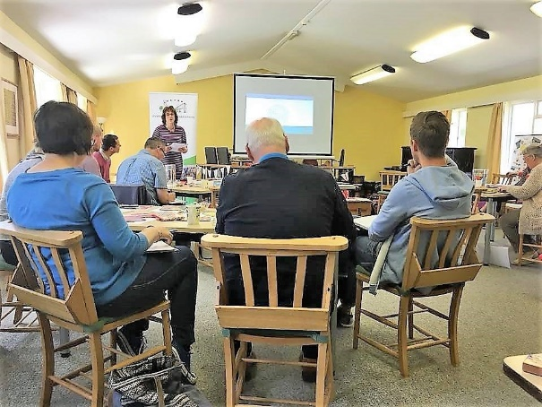
High quality presentation. Speakers excellent.” “Very informative and helpful.”

