Enquiring Minds & Open Hearts:
Religious Education for all

The Agreed Syllabus for RE in Sheffield 2014-2019
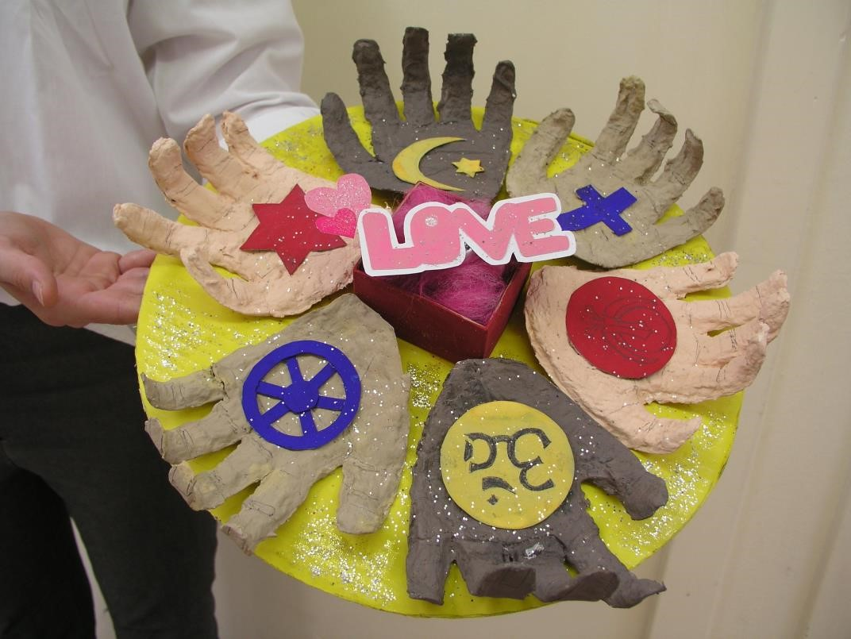

Jess, 13, expresses her vision of
many
religions
, each different, but all

connected by lo
v
e.

Approved at Sheffield SACRE, Agreed Syllabus Conference, June 2014

This syllabus describes RE for schools in Sheffield.
For the schools where it applies, RE is legal if it follows this syllabus.

Contents

Foreword and Introduction | 3
Human Rights and RE: the human quest | 5
The Purpose of Study and the Aim of RE in Three Elements | 6
Religion in Sheffield and in the School Curriculum | 8
RE in the school curriculum in different school types | 9
What must we teach? RE and the law | 10
Spiritual, Moral, Social and Cultural Development through RE | 11
Organising RE
Which religions are to be studied? | 13
Curriculum time for RE | 14
Respect for all, global learning and community cohesion | 16
Subject content for RE by age group
EYFS: RE in the Reception Class | 17
Key Stage 1, 5-7s | 18
Key Stage 2, 7-11s | 22
Key Stage 3, 11-14s | 28
Progression and outcomes, 5-14 | 33
RE for all, 14-19 | 34
Achievements and Outcomes of RE: the Eight Steps
Attainment in RE: processes and outcomes | 35
Additional guidance and acknowledgments | 43
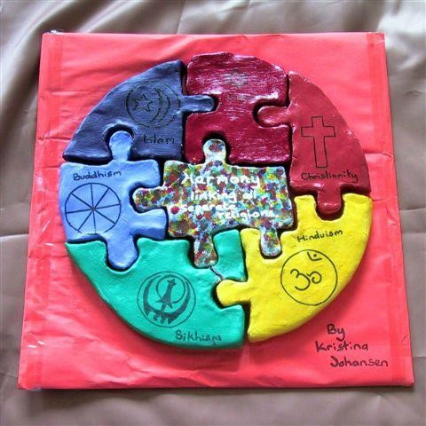

Kristina, 13, shows her idea of
religions linked by harmony

Foreword

We are delighted to write this foreword to our Standing Advisory Council for Religious Education (SACRE’s) Agreed Syllabus for RE in Sheffield, 2014 – 2019 – “Enquiring Minds and Open Hearts: Religious Education for All”.

The new syllabus has been a year in the making and we are very grateful to all those who have given of their time, energy, commitment, knowledge and understanding in order to produce this exciting new document. It has been written by practitioners for practitioners and was commissioned on behalf of Sheffield SACRE by the City Wide Learning Body, our overarching strategic partnership group, which promotes high standards of achievement and attainment for all learners in the city.

The new Agreed Syllabus has been written to provide a good match and fit with the Religious
Education Council of England and Wales “Curriculum Framework for RE in England”, October 2013, endorsed by the Secretary of State for Education, Michael Gove. It is offered to our schools so that they can introduce the new syllabus alongside all the other subjects of the National Curriculum and their revised programmes of study with effect from September 2014.

The range and depth of religions and world views which are encompassed in the new Agreed Syllabus both reflect the diverse nature of Sheffield and provide a rich foundation for all of us to strengthen and enhance community cohesion within and across our city. The working group, facilitated by Lat Blaylock, RE Adviser at RE Today, are to be commended for their thoughtful work in this regard.

We commend the syllabus wholeheartedly to you and wish you great success in the teaching and learning of RE over the coming years.

Jayne Ludlam | Councillor Jackie Drayton
Executive Director | Cabinet Member
Children, Young People and Families | Children, Young People and Families
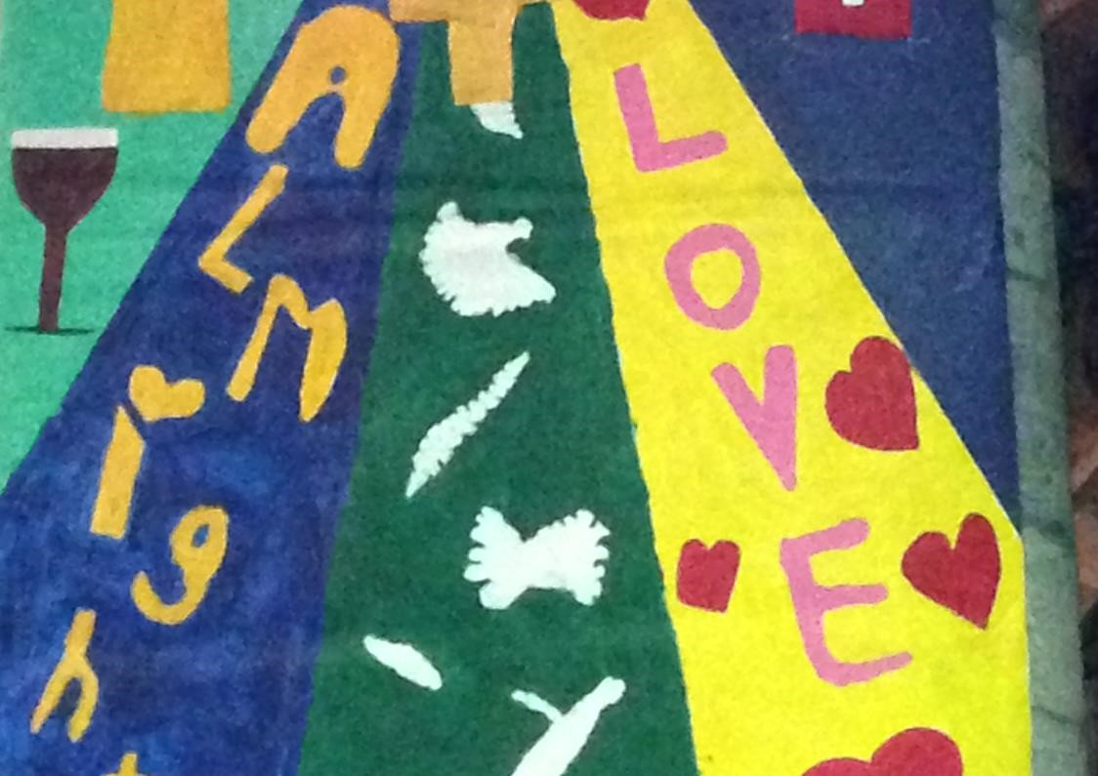
June 2014

June 2014

Pu
pils collage some of the key ideas and values of the Christian faith in Year 3

Introduction

The aim of religious education in Sheffield schools is that pupils will know about and understand a range of religions and worldviews and will express ideas and insights of their own into the significant human questions which religions address.

Religious education in Sheffield schools contributes dynamically to children and young people’s education in schools, provoking challenging questions about human life, beliefs, communities and ideas. In RE pupils learn from religions and world views about different ways of life in local, national and global contexts. They discover, explore and consider many different answers to questions about human identity, meaning and value. They learn to weigh up for themselves the value of wisdom from different communities, to disagree respectfully, to be reasonable in their responses to religions and world views and to respond by express insights into their own and others’ lives. They are encouraged to develop enquiring minds, and to think rigorously, creatively, imaginatively and respectfully about their ideas in relation to religions and world views.

The National Curriculum states the legal requirement that:

“Every state-funded school must offer a curriculum which is balanced and broadly based, and which:
- Promotes the spiritual, moral, cultural, mental and physical development of pupils at the school and of society, and
- Prepares pupils at the school for the opportunities, responsibilities and experiences of later life.”
And:

“All state schools... must teach religious education to pupils at every key stage... All schools must publish their curriculum by subject and academic year online” (DfE National Curriculum Framework, July 2013, page 4).

This new RE Syllabus for Sheffield pupils establishes what shall be taught in RE in Sheffield schools, and provides teachers with practical support and guidance about how to teach RE effectively.

The 2014 Sheffield RE Agreed Syllabus follows the structure of the DfE’s National Curriculum (2013), so that RE has subject documentation which parallels the subjects of the National Curriculum. RE is described in terms of purpose, aims and programs of study for each age group, leading to clear outcomes. The Agreed Syllabus also takes the opportunity to give clear guidance on RE in the early years and RE for students aged 14-19. As RE is a core subject of the curriculum for all pupils we have
followed the ways in which English, Mathematics and Science are described in the National Curriculum, including examples, and notes for key stages 1-3.

In describing progression in RE, the syllabus pictures how pupils will develop increasing understanding of wide areas of RE subject knowledge, and also how pupils can develop religious literacy, including the skills of:
- investigating religions and world views through varied experiences and disciplines;
- reflecting on and expressing their own ideas and the ideas of others with increasing creativity and clarity;
- becoming increasingly able to be reasonable in their responses to religions and world views.
The syllabus is a platform on which high standards and inspiring RE can be built.

Rights and RE: the human quest
The United Nations convention on the Rights of the Child asserts not just the rights to life and security, but many rights that give meaning to life and offer participation to the child in the human quest. Such rights go beyond the basic essentials of life:

- Article 13: The child shall have the right to freedom of expression.

- Article 14: The child shall have the right to freedom of thought, conscience and religion.

- Article 17: The child shall have the right to access to information and material from a diversity of national and international sources, especially those aimed at the promotion of his or her social, spiritual and moral well-being and physical and mental health.

- Article 28: The right of the child to education.

- Article 31: The child shall have the right to participate fully in cultural and artistic life.

Claiming these rights for all children everywhere is a political aspiration. The means by which such rights might be secured are primarily educational. In the UK, many assume that these rights are secure, but a constant commitment by teachers is needed to provide opportunities that make these spiritual, cultural, educational rights available to all.

Religious education, as required by this syllabus, makes a key contribution to the partnerships which promote these rights for every child.

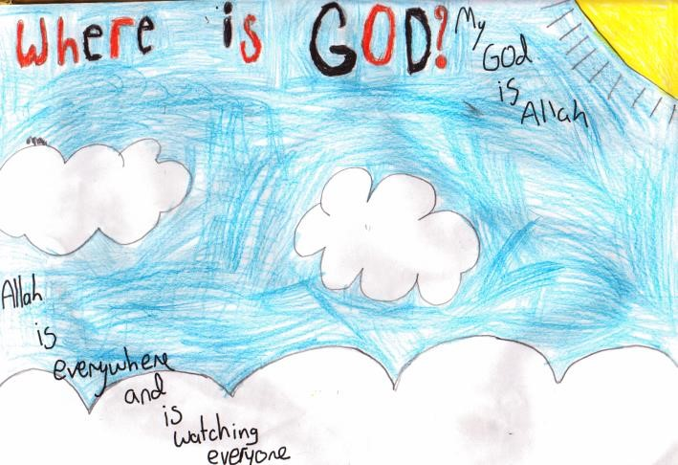  Zain, 8, shows his idea about God using Islamic rules for art | 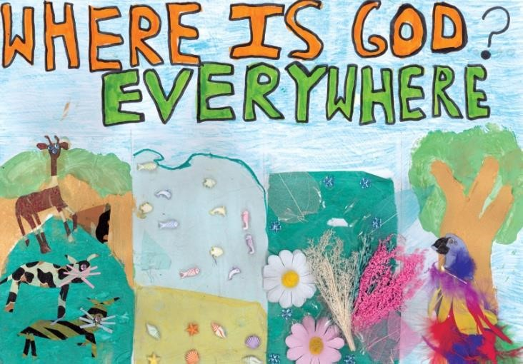  Georgia, 10, shows her idea about God in a collage

Religious Education: Purpose of Study

RE provokes challenging questions about meaning and purpose in life, beliefs about God, ultimate reality, issues of right and wrong and what it means to be human. Teaching should equip pupils with knowledge and understanding of a range of religions and world views¹, enabling them to develop their ideas, values and identity. It should develop an aptitude for dialogue in pupils so that they can participate positively in our society which is diverse in relation to religions and world views. Pupils should learn how to study religions and world views systematically, making progress by reflecting on the impact of religions and world views on contemporary life locally, nationally and globally to increasing levels of complexity and depth. Pupils should gain and deploy the skills needed to interpret and evaluate evidence, texts and sources of wisdom or authority. They learn to articulate clear and coherent accounts of their personal beliefs, ideas, values and experiences while respecting the right of others to have different views, values and ways of life.

The Aim of RE in Sheffield
The curriculum for religious education aims to ensure that all our pupils:
A. Know about and understand a range of religions and world views, so that they can:
A1 Describe, explain and analyse beliefs and practices, recognising the diversity which exists within and between communities;
A2 Identify, investigate and respond to questions posed by, and responses offered by some of the sources of wisdom² found in religions and world views;
A3 Appreciate and appraise the nature, significance and impact of different ways of life and ways of expressing meaning.
B. Express ideas and insights about the nature, significance and impact of religions and world views, so that they can:
B1 Explain reasonably their ideas about how beliefs, practices and forms of expression influence individuals and communities;
B2 Express with increasing discernment their personal reflections and critical responses to questions and teachings about identity, diversity, meaning and value.
B3 Appreciate and appraise varied dimensions of religion³.
C. Gain and deploy the skills needed to engage seriously with religions and world views, so that they can:
C1 Find out about and investigate key concepts and questions of belonging, meaning, purpose and truth, responding creatively;
C2 Enquire into what enables different communities to live together respectfully for the wellbeing of all;
C3 Articulate beliefs, values and commitments clearly in order to explain reasons why they may be important in their own and other people’s lives.

The diagram on the next page shows the aims of the subject in a way that is suited to making a classroom or staffroom poster.

- This syllabus of Religious Education is inclusive, and makes space for non-religious views of life, including examples such as humanism. When we refer to ‘religions and world views’ it is this kind of inclusivity that is signalled. Religions are themselves views of the world, or worldviews, and there are also various non-religious views of the world.
- The sources of wisdom found in religions and world views will include the teachings of some key leaders, key texts and key thinkers from different traditions and communities. Examples are many, but could include the Buddha, Jesus Christ, the Prophet Muhammad, Guru Nanak, Charles Darwin, the Bible, the Torah or the Bhagavad Gita. Other sources of wisdom might come from the contemporary world.
- The RE Program of Study usually refers to ‘religions and world views’ to describe the field of enquiry. Here, however, the aim is to consider religion itself, as a phenomenon which has both positive and negative features, and is open to many interpretations: in this aspect of the aims, pupils are to engage with religion, not merely with individual examples of religions or world views.
The Aim of RE: Three elements Pupils will be taught:

Knowledge and understanding of religions and world views
•Describe, explain and analyse beliefs and practices, recognising the diversity which exists within and between communities;
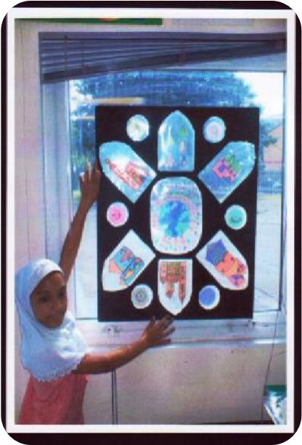
•Identify, investigate and respond to questions posed by, and responses offered by some of the sources of wisdom found in religions and world views;
•Appreciate and appraise the nature, significance and impact of different ways of life and ways of expressing meaning.

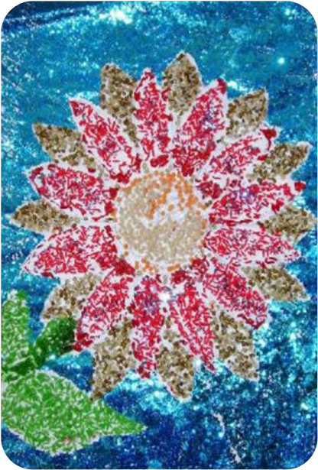
Expression and communication of ideas and insights about the nature, significance and impact of religions and world views
•Explain reasonably their ideas about how beliefs, practices and forms of expression influence individuals and communities;
•Express with increasing discernment their personal reflections and critical responses to questions and teachings about identity, diversity, meaning and value;
•Appreciate and appraise varied dimensions of religion.

Gain and deploy the skills needed to engage seriously with religions and world views
•Find out about and investigate key concepts and questions of belonging, meaning, purpose and truth, responding creatively;
•Enquire into what enables different communities to live together respectfully for the wellbeing of all;
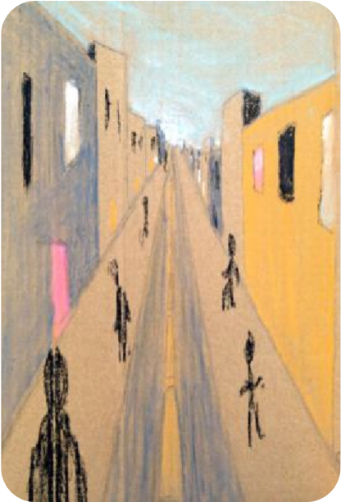
•Articulate beliefs, values and commitments clearly in order to explain reasons why they may be important in their own and other people’s lives.

Religion in Sheffield, the Region and the Nation Census figures from 2011
It is very valuable for pupils to learn about religion as it is in the UK today. Census figures are one source for this kind of enquiry. The tables below provide some basic information, but much more and more detail is available from the website: www.statistics.gov.uk. Secondary pupils can use this website for themselves, with some guidance.

Religion in Sheffield, the region and the UK
(regionally rounded to hundreds or thousands)

Religion / Belief | Sheffield | Yorkshire and Humberside | England and Wales
Christianity | 290 299 | 3 144 000 | 33 243 000
Islam | 42 801 | 326 000 | 2 706 000
Hinduism | 3 566 | 24 000 | 816 000
Sikhism | 942 | 22 200 | 423 000
Judaism | 747 | 9 900 | 263 000
Buddhism | 2 282 | 14 300 | 247 000
Other religious groups | 1 961 | 16 500 | 240 000
No religion | 172 516 | 1 366 000 | 14 097 000
Unstated in the Census | 37 584 | 360 000 | 4 038 000

All pupils should build an accurate understanding of these figures, so that they can see clearly the place of religion in contemporary Britain.

Note that while some populations may be numbered in hundreds or the low thousands in our immediate area, we are educating pupils to live in a region, a nation and a world – not merely in a single city. Religious plurality is the context of RE.

Since 2001, the biggest change has been a 10% increase in the number of non religious people in the UK and a 12% fall in the number identifying themselves as Christians. But Christianity is still selected by 59% of the population as their chosen description of religious identity.

In Sheffield, our population of just over 550 000 includes about 52% Christians (nationally 59%), just under 8% Muslims (nationally 4.8%) and 31% of people with no religion (nationally 25%). RE is for every pupil, and encourages understanding of the whole community.

Our RE syllabus is balanced: pupils will learn from Christianity in each year of their schooling and more than half of their studies will centre on Christianity. A balanced program of learning from others religions and worldviews is offered as well.

RE in the school curriculum in different school types

RE is a statutory subject in each year of the school curriculum of maintained schools. Academies and Free Schools are contractually required through the terms of their funding agreements with DfE to make provision for the teaching of RE to all pupils on the school roll, and Academies in Sheffield are warmly invited by SACRE to use this syllabus, a local, contemporary, practical, supportive and widely approved framework for RE.

The Sheffield 2014 RE Agreed Syllabus has been developed in line with the strategic priorities of the Local Authority and in consultation with the City Wide Learning Body.

RE offers distinctive opportunities to promote pupils’ spiritual, cultural, social and moral development. RE lessons should offer a structured and safe space during curriculum time for learners’ own reflections on meaning and values in life. Teaching in RE should engage pupils in discussion, dialogue and debate which enables them to make their reasoning clear and which supports their cognitive and linguistic development. Teaching in RE lessons should also allow for timely and sensitive responses to be made to unforeseen events of a religious, moral or philosophical nature, whether personal, local, national or global.

The breadth of RE: from local to global
The law requires that RE in schools that are not designated with a religious character “must reflect the fact that the religious traditions in Great Britain are in the main Christian, while taking account of the teaching and practices of the other principal religions represented in Great Britain.”

This means that from ages 4-19 pupils learn about diverse religions and worldviews including Christianity and the other principal religions. Some schools with a religious character will prioritise learning one religion, but all types of school should recognise the diversity of our city, our region, the UK and the world and the importance of learning broadly and deeply about religions and world views, including those with a significant local presence. This may include some minority religious communities as well as those named above.
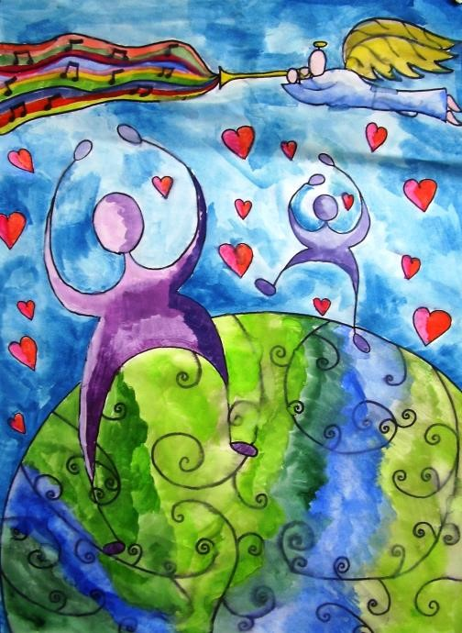

Siobhan, 13, expresses thanksgiving for the
beautiful world

What must we teach? RE and the law.

The statutory requirements for Religious Education in schools

The main statutory requirements relating to RE in schools and the Local Authority’s responsibilities are in the Education Acts 1996 and 2002, the School Standards and
Framework Act 1998, the Children Act 2004 and the Education and Inspections Act 2006. The Department for Education also published its current guidance in “Religious Education in English Schools: Non-Statutory Guidance 2010”. The key points are:

- RE For every child. RE must be provided for all registered pupils on the school roll, from reception classes through to 16-19s in the sixth form. This does not include nursery schools, nursery classes or sixth form colleges but does include as far as practicable PRUs and special schools.

- Parents’ rights. Parents may withdraw their children from RE lessons and require that they are given alternative religious instruction (subject to certain provisions). Schools may have a policy setting out their approach to provision and withdrawal.

- Teachers’ rights. If they choose not to, teachers cannot to be required to teach RE.

- The scope of the syllabus. At community, foundation and voluntary controlled schools without a religious character RE must be taught in accordance with the Local Authority’s Agreed Syllabus

- Faith schools. Denominational voluntary aided schools with a religious character are not required to use the Agreed Syllabus but must follow the requirements of their trust deed or the tenets of their denomination where the trust deed does not specify requirements. The Agreed Syllabus must be taught, however, where parents request it and the child cannot reasonably attend a school where the Agreed Syllabus is being taught.

- Education, not religious nurture. RE provided in compliance with the Agreed Syllabus must not be denominational in character but it is permissible to teach about denominational differences. It must however “reflect the fact that the religious traditions of Great Britain are in the main Christian whilst taking account of the teaching and practices of the other principal religions represented in Great Britain.”

- Inspection. The provision and quality of RE is subject to inspection by OFSTED or by denominational inspection systems in the schools to which they apply.

- RE in Academies. Academies are required by their Funding Agreements with DfE to teach RE to all their pupils but are not required to use their local Agreed Syllabus. Sheffield SACRE warmly invites them to do so however, because this syllabus is local and has been agreed with all major stakeholders.

- Sheffield SACRE and its work. The Local Authority has a statutory responsibility to maintain a Standing Advisory Council on Religious Education (SACRE) to advise the Authority on matters connected with RE.

- Heads and governors: responsible for RE. In relation to community schools, foundation and voluntary schools without a religious character, the Authority, Governing Body and Headteacher have responsibilities to ensure that legal requirements are followed.

Spiritual, Moral, Social and Cultural Development through RE
A distinctive contribution from Religious Education
The Sheffield Agreed Syllabus for RE enables the teaching of RE to make a distinctive and significant contribution to these four aspects of pupils’ learning and wellbeing. While schools provide for these aspects of personal development in many ways, and through many subjects of the curriculum, RE can focus on spiritual and moral development within the curriculum, and makes a distinctive contribution to understanding cultural diversity through developing understanding of religions. These opportunities for personal development contribute to high standards and aspirations for each pupil.

Spiritual development  enables people to increase their self awareness and to look at their human relationships, at the wider world and at their ideas about ultimate reality (for some people, God) with characteristics and values such as courage, hope, strength, insight and love, so that they can better face the sufferings, challenges and opportunities of human life. | Religious education provides opportunities to promote spiritual development through:  - discussing and reflecting on key questions of meaning and truth such as the origins of the universe, life after death, good and evil, beliefs about God and values such as justice, honesty and truth;  - learning about and reflecting on important concepts, experiences and beliefs that are at the heart of different religions and world views;  - considering how beliefs and concepts in religions may be expressed through the creative and expressive arts and related to the human and natural sciences, thereby contributing to personal and communal identity;  - considering how religions and other world views perceive the value of human beings, and their relationships with one another, with the natural world, and with belief about God;  - valuing relationships and developing a sense of belonging;  - developing their own views and ideas on religious and spiritual issues.
Moral development  enables pupils to take an increasingly thoughtful view of what is right and wrong, to recognise the needs and interests of others as well as themselves and develop characteristics and values such as truthfulness, kindness, unselfishness and commitments to virtues such as integrity, justice and the will to do what is right, so that they can live in ways which respect the wellbeing and rights of each person. | Religious education provides opportunities to promote moral development through:  - exploring the values identified by schools and within the National Curriculum, particularly valuing diversity and engaging in enquiries into issues of truth, justice and trust;  - exploring the influence of family, friends and media on moral choices and how society is influenced by beliefs, teachings, sacred texts and guidance from religious and other leaders;  - considering what is of ultimate value to pupils and to religious believers through studying the key beliefs and teachings from religions and worldviews about values and ethical codes of practice;  - studying a range of ethical issues, including those that focus on justice, to promote racial and religious respect, community cohesion and personal integrity;  - considering the importance of rights and responsibilities and developing a sense of conscience.

Social development  enables pupils to relate to others successfully through an understanding of the responsibilities and rights of being a member of various family, local, national and global communities. It enables them to develop social skills, qualities, attitudes and characteristics such as respectfulness, tolerance, a willingness to get involved, so that they can play a full and fulfilling part in their community and society as, for example, family members, citizens, learners and workers. | Religious education provides opportunities to promote social development through:  - considering how religious and other beliefs lead to particular actions and concerns in local, national and global society;  - investigating social issues from diverse perspectives of religion and belief, recognising the range of viewpoints within and between religions and beliefs as well as some common ground between religions and non-religious values;  - articulating pupils’ own and others’ ideas on a range of contemporary social issues, including environmental concerns, issues of equality and respect for all.
Cultural development  enables people to develop their sense of their own place and identity in society, to value and participate creatively in their own culture and appreciate the cultures of others by developing their appreciation of, for example the arts, literature, sport, music, travel and other aspects of culture. Cultural development makes its contribution to human wellbeing through enabling participation in diverse varieties of cultural life for the enrichment of individuals and communities. Cultural development enables people to develop understanding, qualities and attitudes which lead to appreciation or participation in local, regional, national, European and global cultures. | Religious education provides opportunities to promote cultural development through:  - encountering people, literature, the creative and expressive arts and resources from differing faiths and cultures in increasing depth;  - considering the relationships between religion and cultures and how religions and worldviews contribute to cultural identity and practices for many people;  - promoting inter faith harmony and respect, making a positive contribution to a society where different religions and worldviews co-exist, promoting awareness of how interfaith cooperation can sometimes support wellbeing and the pursuit of the common good.  - combating prejudice and discrimination and contributing positively to community cohesion and reducing racism.

Her Majesty’s Inspectors recognise the role RE can play in SMSCD:
“Effective enquiry in RE allows pupils to use their creativity and imagination – ensuring that experiential learning and opportunities to foster spiritual and creative development are built into the process of enquiry.” (RE: Realising the Potential,
OFSTED, 2013, page 24)

Organising RE
Which religions and beliefs are to be studied?

The Sheffield Agreed Syllabus requires that over half of the RE curriculum relates to Christianity. In addition, pupils will learn from the principal religions represented in the UK, in line with the law. These are Islam, Hinduism, Sikhism, Buddhism and Judaism. Furthermore, children from families where non-religious worldviews are held are represented in almost all of our classrooms. These worldviews, including for example Humanism, will also be the focus for study. Religions are to be studied in depth as follows:

Schools should consider the pupils they serve in deciding whether to go beyond the minimum entitlements to learning about religions, which are that pupils should learn from: |  | Non religious world views in RE: Many pupils come from families and communities that practice no religion. Many people reject supernatural explanations of human life. It is recommended  that pupils study non-religious beliefs and ways of life both before the age of 14 and during 14-19 RE. These may include examples such as Humanism and the ideas of people who describe themselves as ‘spiritual but not religious’. | This is the  minimum requirement. Many schools may wish to go beyond the minimum.  Schools should consider the pupils they serve in deciding whether to go beyond the minimum  entitlements to learning about religions and beliefs.  Learning from 4 religions across a key stage is demanding: the syllabus does  not recommend tackling 6 religions in a key stage. Depth is more important than overstretched breadth
4-5s  Reception | Developing a growing sense of the child’s awareness of self, their own community and their place within this, children will encounter Christianity and other faiths found in their own classroom, simply.
5-7s Key  Stage 1 | A minimum of two religions are to be studied. Christianity and at least one other religion (Islam is the recommended example. Judaism is a popular alternative). Religions and beliefs represented in the local area may also be chosen for learning.
7-11s Key  Stage 2 | A minimum of three religions are to be studied. Christianity and at least two other religions (two from Buddhism, Hinduism, Judaism or Islam are recommended).
11-14s Key  Stage 3 | Four religions are to be studied. Christianity, Buddhism, Sikhism and Islam are recommended (an additional study of Judaism and / or Hinduism may also be undertaken).
14-16s Key  Stage 4 | It is recommended that at least two religions, usually including Christianity, are studied. This will usually be through a recognised national RS qualification course such as GCSE full or short RS courses or CoEA RS, but could be through a school devised RE course.
16-19  RE for All | Belief systems or life stances as appropriate

Note A: the range of religious groups in the UK. Groups such as Jehovah’s Witnesses, Latter Day Saints, the Baha’i faith or the Jains are not excluded from study in this scheme for RE. Schools are always advised to make space for the worldviews of the local community, which is why the tablke above expresses minimum requirements
Note B: progression in learning through the primary school. It is good practice for the religion chosen for learning with 4-7s to be a continuing focus for learning with 7-11s, so that progression understanding is possible. In Sheffield, where 43 000 Muslim people live, the recommended example is Islam.

Note C: Plural RE for 14-19s. The 14-19 section of the syllabus gives more detail on different ways for schools to develop their RE / RS courses. Schools studying only Christianity for examination courses must consider carefully how to avoid narrow learning in RS and address the question of the breadth of religious learning carefully.

Organising RE
Curriculum Time for RE in Sheffield

In order to deliver the aims and expected standards of the syllabus, SACRE and the Agreed Syllabus Conference strongly recommends a minimum allocation of curriculum time for RE based upon the law and DfE guidance. A minimum 5% of curriculum time is required for teaching RE. Schools should make plans to give at least this amount curriculum time to the subject as the syllabus is implemented.

This means in practice that schools are expected to allocate:
Reception and Key Stage 1: 36 hours of tuition per year (e.g. 50 minutes a week or some short sessions implemented through continuous provision)
Key Stage 2:45 hours of tuition per year (e.g. an hour a week, or less than an hour a week plus a series of RE days)
Key Stage 3: 45 hours of tuition per year (e.g. an hour a week, RE-centered Humanities lessons taught for 4 hours a week for one term of the year)
14-16s: 5% of curriculum time, or 70 hours of tuition across the key stage (e.g. an hour a week for five terms)
16-19s: Allocation of time for RE for all should be clearly identifiable and should not be tokenistic.

This means that this syllabus for RE can be delivered in an average of approximately an hour of teaching per week.

Notes
- RE is legally required for all pupils. RE is a core subject of the curriculum for all pupils. The requirements of this Agreed Syllabus are not subject to the flexibility of the Foundation Subjects.
- RE is different from assembly. Curriculum time for Religious Education is distinct from the time schools may spend on collective worship or school assembly. The times given above are for Religious Education in the curriculum.
- Flexible delivery of RE is often good practice: an RE themed day, or week of study can complement – but not usually replace - the regular program of timetabled lessons (see additional ideas on the next page).
- RE should be taught in clearly identifiable time. There is a common frontier between RE and such subjects as literacy, citizenship, History or PSHE. But the times given above are explicitly for the clearly identifiable teaching of Religious Education. Where creative cross curricular planning is used, schools must ensure that RE objectives from the syllabus are clearly planned and taught.
- Coherence and progression. Whilst schools are expected to make their own decisions about how to divide up curriculum time, schools must ensure that sufficient time is given to RE so that pupils can meet the standards and expectations set out in this Agreed Syllabus to provide coherence and progression in RE learning.
- Too little time leads to low standards: Any school in which head teachers and governors do not plan to allocate sufficient curriculum time for RE is unlikely to be able to enable pupils to achieve the outcomes set out in this syllabus.

Flexible models of delivery and high standards in RE:
Religious education must be planned for high standards. There are different ways that schools can do this. All Sheffield pupils, 4-19, are entitled to good learning in RE, so schools must plan sufficient time for the subject to be well taught. Subject leaders for RE, senior staff, head teachers and governors will all take an interest in ensuring provision enables the best possible standards. This might be done in various ways:

Whilst there may be occasions where there are planned activities for children in the Early Years, these should always start with the experiences and events which relate to the children and their immediate families. Other opportunities to develop children spiritually and morally and to strengthen their understanding of culture would be planned and delivered through ongoing high quality provision and practice using children’s own experiences and questions as starting points.

A large majority of Sheffield schools use one or two weekly lessons of RE as the standard way of running the curriculum plan. The advantages of this are that pupils get used to the RE lesson, the progress they make can be steady and continuous and teachers ‘know where they are’. The main disadvantage is that pupils’ weekly experience of RE can be too spread out for the deeper learning that the subject requires to flourish.

- Some schools use a themed curriculum approach to RE. A series of lessons in the humanities are themed for RE, e.g. for half a term, and pupils spend four or five hours a week or more doing RE and relating the study to history or geography. In the next half term, the focus may be more on one of the other subjects. The main advantages of this are that pupils get a deeper and more continuous experience of RE. A disadvantage is that some schools use arbitrary themes or fail to plan RE into the program at sufficient depth. Specialist RE teachers’ involvement or a sharp focus on planned RE outcomes in planning is crucial.

- Some schools use an ‘RE Week’ or an ‘RE Day’ to focus learning, then follow up the ‘big experience’ with linked lessons over several weeks. Such ‘big events’ RE planning is demanding of teachers, but can for example help the whole school to focus and develop the subject. A day is about 5 hours, so is not, of course, a substitute for a term’s worth of weekly lessons. The key to success is clarity about the RE learning that is planned. A guide to this kind of opportunity, with some practical ideas and outlines, is available from RE Today, titled ‘Big RE’.

- Creative curriculum planning in which a modular approach to curriculum planning can be used effectively. This approach can present both opportunities and challenges for RE: Why do inspectors sometimes find RE is least well covered in an integrated program of learning? Do some themes enable RE effectively, but do some themes exclude RE? Schools must consider the learning objectives of the syllabus in deciding whether RE learning is well served by ‘creative curriculum planning’.

- Mixed Age Classes: In schools where class groups include children from different year groups, this RE syllabus can be taught in very flexible ways using the guidance and materials the syllabus provides for the different ages in the class.

In deciding the ways in which the Agreed Syllabus will be implemented, schools should ensure that the full range of RE opportunities is offered to all pupils.

Respect for All, Global Learning and Community Cohesion: What does RE offer to pupils?

This Agreed Syllabus provides many opportunities for RE teaching and learning to challenge stereotypical views and to appreciate difference positively.

Learning for diversity. Government guidance advises that “every school is responsible for educating children and young people who will live and work in a country which is diverse in terms of cultures, religions or beliefs”. A recurring theme of government and HMI guidance on Religious Education is to “develop a positive attitude towards other people, respecting their right to hold different beliefs from their own, and towards living in a world of diverse religions.” RE guidance also requires schools to enable pupils to examine the consequences of anti-social behaviour such as racism and to develop strategies for dealing with it. Equally, Ofsted also points to the major contribution that RE makes to “valuing diversity, promoting multicultural understanding and respect.”

Reducing intolerance. Promoting community cohesion aims to contribute to reducing the corrosive effects of intolerance. It is too simplistic to assume that merely by teaching about the major world religions, RE will automatically contribute to community cohesion. It is even possible for weaker teaching to reinforce stereotypes: e.g. ‘Muslims are from Pakistan’ or ‘Christians are white’. It is valuable to note that, for example, Christians, Jews and Muslims all give great significance to Jesus within their religious tradition, holding some aspects in common and diverging on other fundamental points. There is also, of course, great diversity within religions, where different interpretations can clash sharply. As well as learning about the historical and current relationship between cultures, pupils should study the ways in which one religion has influenced the development of another.

Visits and visitors: RE is the ideal vehicle for building links with faith communities in the local area of the school. Pupils need opportunities to meet people of different faiths and cultures to develop a respect for those who believe, think and practice differently, without feeling that their own identity or views are threatened. In fact, pupils can deepen and clarify their sense of identity through their encounter with the ‘other’. It is important to set ground rules for discussion when religious differences are explored, in order to create a safe and positive environment. This is particularly relevant where there may be media misrepresentations and commonly held negative stereotypes e.g. Islamophobic ideas, unfair negativity to any religion.

Breadth – cohesion for all. In terms of community cohesion in Sheffield, it is more meaningful to pupils if the religions taught include those of their own families and communities, including smaller faith groups in order to accord equal value and respect. Similarly, children should learn that non-religious perspectives on life, including examples such as Humanism, are also valid and widespread. Large numbers of our pupils come from families where no religion is practiced and they must not be made to feel that their lives or families are less worthy as a result.

Planned support for teaching. At key stages 2 and 3 there are planned units for investigating these important issues. For Year Key Stage 2, see the unit on ‘Enquiring into places of worship through visits’ and for Years 7-9 ‘How can Sheffield become a more respectful city?’

Subject content in RE

RE in the Early Years Foundation Stage
Pupils should encounter religions and world views through special people, books, times, places and objects and by visiting places of worship. Continuous provision that includes RE outcomes and goals is central to this model of RE for the Reception class. Pupils should listen to and talk about stories. Pupils can be introduced to subject specific words and use all their senses to explore beliefs, practices and forms of expression. They ask questions and reflect on their own feelings and experiences. They use their imagination and curiosity to develop their appreciation of and wonder at the world in which they live. Religious Education is, unlike the subjects of the National Curriculum, a legal requirement for all pupils on the school roll, including all those in the reception year.

In line with the DfE’s 2013 EYFS Profile RE should, through planned, purposeful play and through a mix of adult-led and child-initiated activity, provide these opportunities for pupils.
Communication and Language:
- Children listen with enjoyment to stories, songs and poems from different communities and traditions and respond with relevant comments, questions or actions;
- They use talk to organise, sequence and clarify thinking, ideas, feelings and events;
- They answer ‘who’, ‘how’ and ‘why’ questions about their experiences in response to stories, experiences or events from different traditions and communities;
- They talk about how they and others show feelings;
- They develop their own narratives in relation to stories they hear from different communities.
Personal, Social and Emotional Development.
- Children understand that they can expect others to treat their needs, views, cultures and beliefs with respect;
- They work as part of group, taking turns and sharing fairly, understanding that groups of people need agreed values and codes of behaviour, including adults and children, to work together harmoniously;
- They talk about their own and others’ behaviour and its consequences, and know that some behaviour is unacceptable;
- They think and talk about issues of right and wrong and why these questions matter;
- They respond to significant experiences showing a range of feelings when appropriate;
- They have a developing awareness of their own needs, views and feelings and be sensitive to those of others;
- They have a developing respect for their own cultures and beliefs, and those of other people. • They show sensitivity to others’ needs and feelings, and form positive relationships.
Understanding the World
- Children talk about similarities and differences between themselves and others, among families, communities and traditions;
- They begin to know about their own cultures and beliefs and those of other people;
- They explore, observe and find out about places and objects that matter in different cultures and beliefs.
Expressive Arts and Design
- Children use their imagination in art, music, dance, imaginative play, and role- play and stories to represent their own ideas, thoughts and feelings;
- They respond in a variety of ways to what they see, hear, smell, touch and taste.
Literacy
- Children are given access to a wide range of books, poems and other written materials to ignite their interest. Mathematics
- Children recognise, create and describe some patterns, sorting and ordering objects simply.

These learning intentions for RE are developed from relevant areas of the Early Years
Foundation Stage Profile (DfE, 2013). RE subject leaders will want to provide detailed examples.

Key Stage 1 RE
The Focus of RE for KS1 enables children to develop their knowledge and understanding of religions and world views. They find out about simple examples of religion that are local, national and global contexts. They should use basic subject specific vocabulary. They should raise questions and begin to express their own views in response to the material they learn about and in response to questions about their ideas.

The aim of RE is expressed in age appropriate outcomes for most 7 year olds.

Specifically pupils should be taught to:

Know about and understand religions and world views | Express ideas and insights into religions and world  views | Gain and deploy the skills for learning from religions and world views
A1. Recall and name different beliefs and practices, including festivals, worship, rituals and ways of life, in order to find out about the meanings behind them; | B1. Ask and respond to questions about what communities do, and why, so that they can identify what difference belonging to a community might make; | C1. Explore questions about belonging, meaning and truth so that they can express their own ideas and opinions in response using words, music, art or poetry;
A2. Retell and suggest meanings to some religious and moral stories, exploring and discussing sacred writings and sources of wisdom and recognising the communities from which they come; | B2. Observe and recount different ways of expressing identity and belonging, responding sensitively for themselves; | C2. Find out about and respond with ideas to examples of co-operation between people who are  different;
A3. Recognise some different symbols and actions which express a community’s way of life, appreciating some similarities between communities; | B3. Notice and respond sensitively to some similarities between different religions and world views. | C3. Find out about questions of right and wrong and begin to express their ideas and opinions in response.
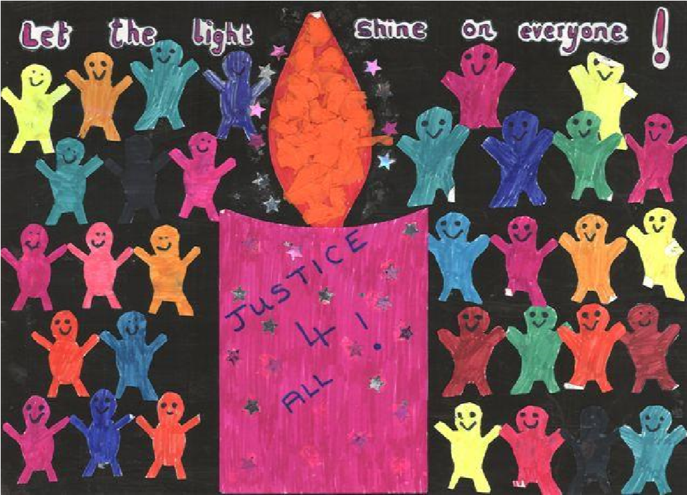

Katy, 7, made her logo for RE all about light

Using the program of study for Key Stage 1:
- Flexible planning: The program of study on the following pages is the recommended way of achieving the required outcomes, but schools may plan other programs of study to achieve this if they wish.
- The order of teaching here is recommended to enable continuity and progression in learning, but again teachers could plan this differently to meet learning needs in their own schools.
- Content selection: schools are required to plan for over half of the content of RE to be drawn from Christianity.
- Continuity and progression: getting learners ready for KS2. For pupils to be able to tackle the KS2 program of study, good standards of learning and understanding based on the full program of study in RE, working towards the outcomes specified for seven year olds are essential.

High quality guidance and support: planned investigations for teachers
Among the detailed guidance and support materials Sheffield SACRE provides for RE, teachers should use the planned investigation exemplars. For Reception and Key Stage 1, there are four planned units:
- Playful RE: examples of play based provision
- Who celebrates what, and why? Christians and Muslims
- What can we learn from stories of Jesus about praying and about helping people?
- Beginning to learn from Muslims and Mosques: What is it like to be a Muslim in Sheffield?

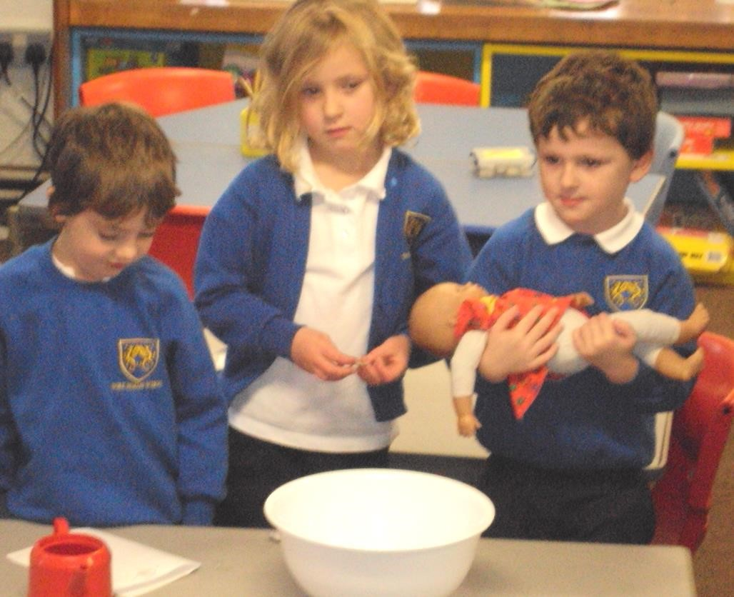

Year 1 pupils engage with RE through play by enacting a baptis
m to
welcome a new baby to the community

A long term Key Stage Plan using 7 planned investigations for RE 5-7 (3 for Year 1, and 4 for Year 2)
Unit plan titles | Teaching and learning: What questions will be addressed? What learning will go on? Which aspects of the aim will be met?
A. Celebrations and festivals:  Who  Celebrates what and why?  Christians and  Muslims | - Pupils explore stories and celebrations of Easter and Id ul Fitr, finding out about what the stories told at the festivals mean, e.g. through hearing and working with stories, enacting celebrations, learning from artefacts or welcoming visitors to talk about their festivals. They engage with the social and emotional aspects of celebrations (A1);  - Pupils select examples of religious artefacts from Christianity or Islam that interest them, raising lists of questions about them and finding out what they mean and how they are used in festivals and for example in community life, prayer and worship (A3);  - Pupils find out about what different religions and world views do to celebrate the fruitfulness of the earth (e.g. in Harvest Festivals, or by Muslim Zakat charitable giving and in generosity to those in need). They respond sensitively to questions about being generous and being thankful (B1);  - Pupils notice and talk about the fact that people come from different religions.  How can we tell? How can we live together when we are all so different? (C2).
B. Myself  How do we show we care for others? Why does it matter? | - Pupils hear three moral stories, for example from Christians, Muslims and humanists. They think and talk about whether they are saying the same things about how we should behave (A3);  - Pupils express creatively (e.g. in art, poetry or drama) their own ideas about the questions: Who am I? Where do I belong? How are we all connected? (B2);  - Pupils notice and talk about the fact that people come from different religions. How can we tell? How can we live together when we are all so different? (C2);  - Linking to English, pupils ask questions about goodness, and create simple sentences that say what happens when people are kind, thankful, fair or generous, and what happens when people are unkind, ungrateful, unfair or mean (C3).
C. Stories of Jesus:  What can we learn from stories of  Jesus about praying and helping people? | - Pupils retell (for example through drama or in pictures) two different stories about Jesus, considering what they mean. Good examples: Jesus and the Ten Lepers. The Lost Coin. They compare the stories and think about what Christians today learn from the stories (A2);  - Linking to English, pupils respond to stories about Jesus, such as the nativity, the Baptism of Jesus, a parable such as the Lost Sheep, a miracle story such as the healing of a blind person. They identify and talk about the values which different characters in the stories showed, and recognise Christianity as the religion from which the stories come (A2);  - Pupils ask and answer ‘who’, ‘when’, ‘where’, ‘how’ ‘what if…’ and ‘why’ questions about religious stories (A2);  - Linking to ‘Philosophy for Children’, pupils think about and respond to ‘big questions’ in a classroom enquiry using, for example, a story from the New  Testament or a video clip of children asking questions about God or some examples of prayers as a stimulus (C1).

D. Symbols  In what ways are churches / mosques / synagogues important to believers? | - Pupils learn from visiting sacred places. Linking to English and computing, pupils recount a visit to a local church, mosque or synagogue using digital photographs. They find out about the meanings of symbols for God in the church, mosque or synagogue and suggest meanings for symbols (A1);  - Pupils find out about the symbols of two different communities, looking for similarities between the ways they use common symbols such as light, water, trees or rock (A3); ▪ Pupils use a set of photos and a list of religious items they have encountered in Key Stage 1 RE to sort and order, saying which items are connected to a particular religion and which are connected to more than one religion. Good examples from Islam might include Muslim artefacts (prayer mat, subha beads, compass, Qur’an stand) and photographs from a local mosque (B3).  - Pupils look at how different people including Muslims and Christians have expressed their ideas about God, and think and talk about their own ideas about God, raising questions and considering different replies. They express ideas using images (C3).
E. Leaders:  What makes some people inspiring to others? | - Pupils hear and retell three moral stories of key leaders, for example from Christians, Muslims and a non-religious story. They talk about how leaders make a difference to our lives. They think about whether the different stories are saying the same things about how we should behave. They consider questions about being good, kind, forgiving and generous (A3);  - Pupils encounter many examples of simple ‘wise sayings’. They choose their favourite ‘wise sayings’ from different key leaders and talk about what makes these sayings wise, and what difference it would make if people followed them (A2);  - Pupils ask and find out how to answer a range of ‘how’ and ‘why’ questions about how people practice their religion, including how they follow their leaders by remembering, telling stories, celebrating, praying or making music. Pupils might use exciting photographs or works of art to stimulate their questions (C2).
F. What does it mean to belong?  Beginning to learn about Islam: What  is it like to  be a Muslim in Sheffield today? | - Linking to English and computing, pupils recount a visit to a local Mosque using digital photographs. They find out about the meanings of symbols and artefacts that they saw there. They learn about what happens at a mosque, especially about Muslim daily prayers (A1);  - Pupils discuss reasons why some people go to mosques, synagogues or churches often, but other people never go to holy buildings, and why some people pray every day, but others not at all (B1);  - Linking to PSHE, pupils make lists of the different groups to which they belong and consider the ways these contribute to human happiness (B1);  - Pupils express creatively (e.g. in art, poetry or calligraphy) their own ideas and responses to questions such as: Who is a Muslim? What is a religion? Who am I? Where do I belong? How can we all get along well? (B2)  - Linking to English, pupils use key words (e.g. holy, sacred, scripture, festival, symbol, humanist) to present ideas or write about the Muslim religion (B3);  - Pupils discuss stories of co-operation from Islam and from different traditions and sources and make a ‘Recipe for living together happily’ or a ‘Class charter for more kindness and less fighting’ (C2);  - Linking to English and PSHE pupils could play some collaborative games, and talk about how the games put the teaching of the ‘Golden Rule’ into action (C2).
G. Believing:  How and why do people pray? (Christians,  Muslims and Jewish people) | - Pupils learn about praying in many different ways. Pupils choose between different examples of simple prayers: which do they think are wise? They talk about what makes the prayers wise, and find out about how and why people pray in different religions. They think and write creatively and thoughtfully about prayer (A2);  - Linking to English, pupils use key words (e.g. holy, sacred, scripture, festival, symbol, Christian, Muslim, Jew) to present simple ideas about 2 or 3 different religions about which they have learned, perhaps in a collaborative classroom display, class book or in assemblies (B3);  - Pupils work in groups to use art, music and poetry to respond to ideas about God from different religions and world views, expressing ideas of their own and commenting on some ideas of others (C1);  - Pupils look at how different people have expressed their ideas about God, and think and talk about their own ideas about God, linking to work with enquiry methods from Philosophy4Children (C3).

Key Stage 2 RE

The Focus of RE for KS2 enables pupils to extend their knowledge and understanding of religions and world views, recognising their local, national and global contexts. They should be introduced to an extended range of sources and subject specific vocabulary. They should be encouraged to be curious and to ask increasingly challenging questions about religion, belief, values and human life. Pupils should learn to express their own ideas in response to the material they engage with, identifying relevant information, selecting examples and giving reasons to support their ideas and views.

The aim of RE is expressed in age appropriate outcomes for most pupils at age 11

Specifically, pupils should be taught to:

Know about and understand religions and world views | Express ideas and insights into the significance of religion and world views | Gain and deploy skills for engaging with religions and world views
A1. Describe and make connections between different features of the religions and world views they study, discovering more about celebrations, worship, pilgrimages and the rituals which mark important points in life in order to reflect thoughtfully on their ideas; | B1. Observe and understand varied examples of religions and world views so that they can explain, with reasons, their meanings and significance to individuals and communities; | C1. Discuss and present thoughtfully their own and others’ views on challenging questions about belonging, meaning, purpose and truth, applying ideas of their own thoughtfully in different forms including (e.g.) reasoning, music, art and poetry;
A2. Describe and understand links between stories and other aspects of the communities they are investigating, responding thoughtfully to a range of sources of wisdom and to beliefs and teachings that arise from them in different communities; | B2. Understand the challenges of commitment to a community of faith or belief, suggesting why belonging to a community may be valuable, both in the diverse communities being studied and in their own lives. | C2. Consider and apply ideas about ways in which diverse communities can live together for the well being of all, responding thoughtfully to ideas about community, values and respect;
A3. Explore and describe a range of beliefs, symbols and actions so that they can understand different ways of life and ways of expressing meaning; | B3. Observe and consider different dimensions of religion, so that they can explore and show understanding of similarities and differences between different religions and world views; | C3. Discuss and apply their own and others’ ideas about ethical questions, including ideas about what is right and wrong and what is just and fair, and express their own ideas clearly in response.

How to use the Program of Study
- Flexible planning: The program of study on the following pages is the recommended way of achieving the required outcomes, but schools may plan other programs of study to achieve this if they wish.
- Teaching order: The order of teaching here is recommended to enable continuity and progression in learning, but again teachers could plan this differently to meet learning needs in their own schools.
- P4C: Sheffield teachers are encouraged to make appropriate use of the methods of the community of enquiry and of philosophy for children in their RE work. Many RE topics will be energized by the use of stimulating religious material such as film, text, poetry, prayer or art in the community of enquiry approach.
- Content selection: Schools are required to plan for over half of the content of RE to be drawn from Christianity.
- Continuity and progression: getting learners ‘secondary ready’. For pupils to be able to tackle the KS3 program of study, good standards of learning and understanding based on the full program of study in RE is essential. Working over the four years of Key Stage 2 to achieve the outcomes expected for 11 year olds requires a well planned programme of learning.

High quality guidance and support: planned investigations for teachers
Among the detailed guidance and support materials Sheffield SACRE provides for RE, teachers should use the planned investigation exemplars.
For Key Stage 2, there are five planned units:
- Beliefs and Symbols: Similar or different? (Christians, Muslims, Sikhs)
- Enquiring into places of worship through visits
- What can we learn from reflecting on Sikh, Muslim and Christian words of wisdom?
- How and why do Muslims and Jews pray?
- Why is Jesus an inspiring person to many people today?

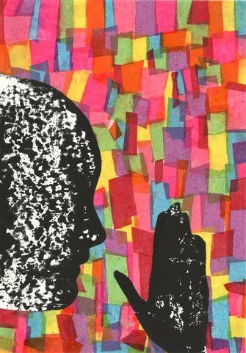

Olivia, 10, made an image of prayer to express her belief
that
‘
y
o
u can speak to God about everything
.’

A long term Key Stage Two Plan using 12 planned investigations for RE 7-11 (3 for each year group)

Unit plan titles | Teaching and learning: What questions will be addressed? What learning will go on? Which aspects of the aim of RE will be met?
Year 3: Beliefs and questions:  How do Christian people’s beliefs about God, the world and others have an impact on their lives?  Christianity | Pupils:  - Learn about Christian celebrations and commitments by describing some spiritual ways of celebrating Christian festivals, including Christmas, Easter and Pentecost. They reflect thoughtfully on the reasons why some people  value such celebrations very highly, but others not at all (A1);  - describe and understand links between Bible stories of creation and  Christian beliefs about God as the creator (A2);  - express and communicate their understanding of the challenges of commitment for a Christian person and a Christian community. They consider: what difference does believing in Jesus make to Christians? (B2);  - discuss a range of ideas about some ‘big questions’, e.g. what do Christians believe about God? What different views do we know about the beginnings of life on Earth? Did God make us all, or are we an accident? Or are there other explanations for humanity? They develop ideas about different ways science and religions handle questions of origins, where we come from (C1).
Year 3: Religion, family and community: Prayer  How do religious families and communities live out their faith?  Religions:  Jewish and Muslim | Pupils:  - pursue an enquiry into Jewish and Islamic prayer, finding out about and exploring beliefs about worship, prayer, God and human life for Jewish and Muslim people (A3);  - find out about the meanings of symbols, words and actions used in prayer and worship such as bowing down, using ritual and symbol, praying alone and in groups (A3);  - find out about similarities and differences in Jewish and Muslim prayer and understand how the practices of prayer for Jewish and Muslim people can bring the community together (B2);  - investigate the meaning of prayer in these communities, considering questions about who prays and why some people believe God answers their prayers. They consider the values expressed in prayers for themselves, connecting ideas from different religions (B2).
Year 3: The journey of life and death:  Why do some people  think life is like a journey? Where do we go? What do people think about life after death?  Christians, Hindus,  Muslims or Buddhists | Pupils:  - find out about and describe some ways in which different religions see life as a journey, for example by considering scriptures as ‘guide books for living’ (A1);  - make connections between different features of the religions and world views they study, discovering more about celebrations, worship, and the rituals which mark important points in life in order to reflect thoughtfully on their ideas (A1);  - compare how Christians, Muslims or Hindus celebrate a new baby’s birth, becoming an adult, a marriage or the life of someone who has died and reflect on ideas of their own about life’s milestones in discussions or in writing (B1);  - develop their understanding of beliefs about life after death in two religions through seeking answers to their own questions and articulating reasons for their own ideas and responses in discussion, creative work and debate (B1)  - develop understanding of links between beliefs, e.g. resurrection and heaven in Christianity, enlightenment and Nirvana in Buddhism (C1)

Year 4: Inspirational people in today’s world  What can we learn from great leaders and inspiring examples in today’s world?  Hindu, Christian,  Buddhist | Pupils:  - experience well told story telling, and develop their own skills as story tellers in relation to ‘great lives’ in religious story (A2)  - describe the lives of some inspirational spiritual and leaders from the modern world (A2)  - understand how key leaders can be sources of wisdom for religious believers (A2)  - explore the lives of key religious leaders from contemporary life, describing the challenges they have faced and the commitments by which they lived (B2)  - apply ideas of their own by giving reasons for their views about how leaders can provide wisdom and inspiration (C1)  Note: these leaders might be world famous examples (Gandhi, Pandurang Shastri Athavale, Mother Teresa, Martin Luther King, the Dalai Lama), or those who serve the community locally, in Sheffield for example.
Year 4: Symbols and religious expression:  How do people express their religious and spiritual ideas on pilgrimages?  Muslims and  Christians | Pupils:  - find out about some interesting examples of religious pilgrimages, gathering knowledge and developing understanding (A1)  - consider why people go on pilgrimages. They use a range of exciting stimuli to find out about pilgrimages, and make some connections between Hajj for Muslims and pilgrimage to Lourdes, Iona or the ‘Holy Land’ for Christians, describing the motives people have for making spiritual journeys. They might imagine planning a pilgrimage in detail to show they can connect spiritual ideas with religious practice (A1);  - linking to English, pupils find out more about different forms of worship, prayer and meditation in different communities, and write creatively and thoughtfully some songs, prayers or meditations suited to particular occasions and communities (B3);  - Linking with the expressive arts curriculum, pupils create works of art or music which express their understanding of what it means to belong to a religion or world view, reflecting on their work on pilgrimage, symbol and religious expression. For example, pupils might plan a pilgrimage / ‘spiritual journey’ for younger children around the school grounds (C1).
Year 4:  Inspirational people from long ago:  What can we learn from inspiring leaders who started religions?  Moses, the  Buddha, Jesus and Muhammad. | Pupils:  - respond thoughtfully to Jewish stories about Moses as the servant of God, learning from stories of the Exodus and the 10 Commandments about how Jewish ideas, festival (Pesach) and stories are connected (A2);  - respond thoughtfully to Christian beliefs about Jesus as God come down to earth, learning from stories of his life, teaching and example, connecting stories about Jesus to Christian beliefs (A2)  - consider how the meanings of a parable of Jesus are expressed in poetry, video, stained glass and drama, weighing up the effectiveness of the different media (A3)  - respond thoughtfully to Muslim teaching about Prophet Muhammad[_{PBUH]} and the revelation of the Qur’an, learning from selected stories of his life (hadith), and making connections between Muslim teaching and Muslim practice (e.g. in the 5 Pillars) (A2);  - respond thoughtfully to stories about the birth, search and enlightenment of the Buddha (A2)  - use their thinking about stories of Moses, the Buddha, Jesus or Muhammad to explore how Jews, Christians and Muslims today celebrate key events from their history (e.g. in Passover, Lent or Ramadan) (B3)  - discuss and present thoughtfully their own and others’ views about the ways in which leaders in religions inspire their followers, connecting to human rights (C1)

Year 5: Religion Pupils:
and the ▪ learn about devotion and commitment in Christianity. They consider why
Christians celebrate Jesus’ birth: what is the meaning of Christmas? They compare
individual: the texts in the Christian gospels that tell the stories of shepherds and wise men at Jesus’ birth, exploring how they are remembered and celebrated in a range of What is expected Christmas festivities (A2);
of a person in ▪ use their detailed understanding of religious practice such as remembering Jesus following a with bread and wine in Christian worship and trying to follow the teaching of Jesus about forgiveness and loving your enemies to describe the significance of being
religion or part of the Christian religion (B1); belief? ▪ discuss and apply their own ideas about ethical questions and human rights issues: what is fair and unfair? Why do people fight and cause pain? How do we know what
Christians is good? Can people learn to be more generous? They learn from examples of
Christian practice and consider the challenges of trying to live a good life (C3).
Year 5: Beliefs Pupils:
and questions: ▪ explore and respond thoughtfullyBuddhists, using a range of sources of wisdom (A2) to the spiritual paths of Muslims, Hindus or
How do people’s ▪ describe the impact of examples of religious teaching. A Hindu example might be the impact of Hindu teaching about harmlessness (ahimsa) on questions about what
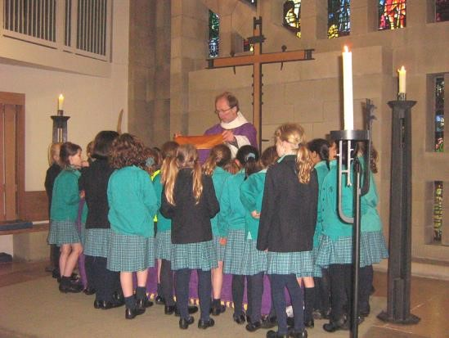
beliefs about we eat and how we treat animals. A Muslim example might be the impact of daily God, the world prayer and Zakat (alms giving) on how Muslim individuals and communities live. A and others have Buddhist example might be about the practice of harmlessness (A3) impact on their ▪ express their own ideas about religious issues and questions, giving reasons for their thoughts (A3)
lives? ▪ discuss and debate reasons why different people have different ideas about

Two from whether God is real and what God is like, recognising the right to freedom of religion and belief for all people (C1)
Muslims, Hindus and Buddhists Year 5: Worship Pupils: and sacred ▪ pursue an enquiry into local places of worship and beliefs about worship. The
methods of philosophy for children can be used effectively here. The pupils relate
places: the meanings of symbols and actions used in worship to events and teachings from
the religions they study (A3);
Where, how and ▪ consider: what happens in holy buildings? Linking to History and design technology why do people pupils consider how the architecture, furniture and use of churches, mosques,
worship? synagogues, mandirs, viharas / Buddhist centres or gurdwaras expresses the community’s way of life, values and beliefs (B1);
Investigating ▪ discuss and present thoughtfully their own and others’ views on challenging places of questions about different kinds of religious belonging in Sheffield and Yorkshire
today, presenting what they have found out about worship clearly and thoughtfully
worship in in a variety of ways including for example design and modeling, photo album Sheffield and descriptions and recounts, Q&A, poetry or art (C1). Yorkshire.

Learning from visiting places of worship is important in KS2 RE

Year 6: Teachings, wisdom and authority:  What do sacred texts and other sources say about God, the world and human life? What can we learn by reflecting on words of wisdom from religions and worldviews  Jewish, Buddhist,  Muslim, Christian | Pupils:  - respond thoughtfully to a range of sources of wisdom and to beliefs and teachings that arise from them in different religions (A2)  - linking to English, pupils consider why some texts from the Torah (e.g. the Shema), the Bible (e.g. 1 Corinthians 13) and the Qur’an (e.g. The 1st Surah, the Opening) are seen as sources of wisdom in different communities. They respond thoughtfully to the ideas found in the texts with ideas of their own (A2)  - linking to Citizenship Education and the methods of philosophy for children, pupils consider, for example, the Ten Commandments (Jewish) and the Five Precepts (Buddhist), expressing thoughtful ideas about what is right and wrong in the light of their learning (C3)
Year 6: Religion, family and community:  What contributions do religions make to local life in Sheffield? How can we make Sheffield a city of tolerance and respect?  All the religions and beliefs of Sheffield | Pupils:  - investigate aspects of community life such as weekly worship, charitable giving or beliefs about caring for others, showing their understanding and expressing ideas of their own (A2)  - linking to the expressive arts, pupils develop their own imaginative and creative ways of expressing some of their own commitments such as working hard at sport or music, caring for animals, loving the family or serving God (B2)  - list and describe similarities and differences between the ways different communities show that they belong (C1)  - linking to Mathematics and Geography, pupils use local and national census statistics to develop accurate understanding of the religious plurality of their locality and of Britain today (C2)  - discuss and apply ideas from different religious codes for living (e.g. Commandments, Precepts or Rules), to compile a charter of their own moral values, applying their ideas to issues of respect for all (C2)
Year 6: Beliefs in action in the world:  How do religions and beliefs respond to global issues of human rights, fairness, social justice and the importance of the environment?  Jewish, Christian, Muslim | Pupils:  - discover and explore what Jewish people, Humanists and Christians teach about how we can all live together for the wellbeing of each other (C1)  - apply their ideas about justice and fairness to the work of three development charities such as Christian Aid, Islamic Relief and Oxfam (C3)  - write persuasively about the reasons why members of different religions and beliefs try to help people who are vulnerable (e.g victims of natural disasters, people who live with disabilities or people affected by war) (C3)
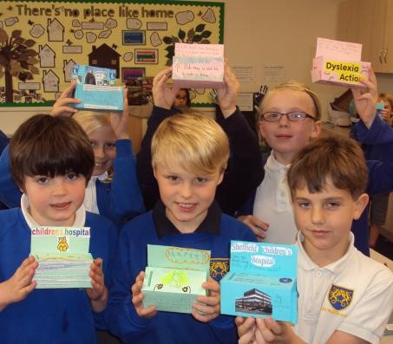

Creative reflection activities enable

pupils to express their own insights

Key Stage 3 RE

Students should extend and deepen their knowledge and understanding of a range of religions and world views, recognising their local, national and global context. Building on their prior learning, they learn to appreciate and appraise religions and world views in systematic ways. They should draw on a wide range of subject specific language confidently and flexibly, learning to use the concepts of religious study to describe the nature of religion. They should understand how beliefs influence the values and lives of individuals and groups, and how religions and world views have an impact on wider current affairs. They should be able to appraise the practices and beliefs they study with increasing discernment based on interpretation, evaluation and analysis, developing their capacity to articulate well-reasoned positions.

The aim of RE is expressed in age appropriate outcomes for most 14 year olds.

Specifically students should be taught to:

Know about and understand religions and worldviews | Express ideas and insights into religions and worldviews | Gain and deploy the skills needed to study religions and worldviews seriously
A1. Explain and interpret ways that the history and culture of religions and world views influence individuals and communities, including a wide range of beliefs and practices in order to appraise reasons why some people support and others question these influences; | B1. Explain the religions and world views which they encounter clearly, reasonably and coherently; evaluate them, drawing on a range of introductory level approaches recognised in the study of religion or theology; | C1. Explore some of the ultimate questions that are raised by human life in ways that are well-informed and which invite reasoned personal responses, expressing insights that draw on a wide range of examples including the arts, media and philosophy;
A2. Explain and interpret a range of beliefs, teachings and  sources of wisdom and authority in order to understand religions and world views as coherent systems or ways of seeing the world; | B2. Observe and interpret a wide range of ways in which commitment and identity are expressed. They develop insightful evaluation and analysis of controversies about commitment to religions and world views, accounting for the impact of diversity within and between communities; | C2. Examine and evaluate issues about community cohesion and respect for all in the light of different perspectives from varied religions and world views;
A3. Explain how and why individuals and communities express the meanings of their beliefs and values in many different forms and ways of living, enquiring into the variety, differences and relationships that exist within and between them. | B3. Consider and evaluate the question: what is religion? Analyse the nature of religion using the main disciplines by which religion is studied. | C3. Explore and express insights into significant moral and ethical questions posed by being human in ways that are well-informed and which invite personal response, using reasoning which may draw on a range of examples from real life, fiction or other forms of media.

Using the program of study
- The program of study on the following pages is the recommended way of achieving the required outcomes, but schools may plan other programs of study to do this if they wish, or may use different examples from other religions and worldviews to enable learners to achieve the outcomes of the syllabus
- A broad, deep and creative RE for 11-14s: whilst SACRE recognises the fact that many schools begin to teach GCSE courses in what is technically KS3, the breadth, depth and diversity of KS3 RE ought not to be sacrificed to this kind of expediency.
- SACRE plans a project to resource these units of work during the lifetime of the syllabus.
- The order of teaching is recommended for progression in learning, but again teachers could plan this differently to meet learning needs in their own schools.
- Schools are required to plan for over half of the content of RE to be drawn from Christianity.
High quality guidance and support: planned investigations for teachers
Among the detailed guidance and support materials Sheffield SACRE provides for RE, teachers should use the planned investigation exemplars.
For Key Stage 3, there are three planned units:
- Does it make sense to believe in God? Exploring Christian ideas • Religion: is it a cause of conflict or a power for peace?
- How can Sheffield become a more respectful city?

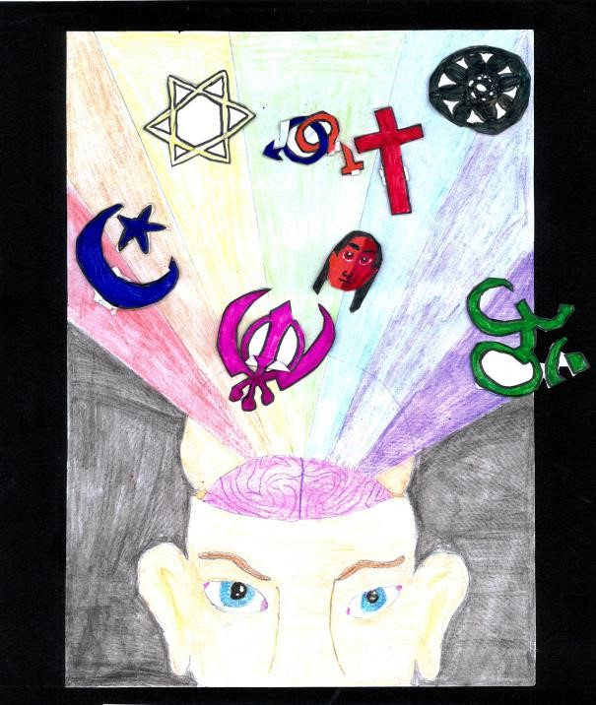

RE promotes open mindedness between

different religions and worldviews.

Sam, 14, created this image of the open mind

KS3 [possibly Year 7]: | Recommended investigations: process and outcomes
1. Unit title: What are the challenges of being a Christian, a Muslim and / or an Atheist in Sheffield today?  Theme: Beliefs and concepts: the key ideas and questions of meaning in religions and beliefs, including issues related to God, truth, the world, human life, and life after death  Religions and worldviews suggested (flexible): students may learn from Christians,  Muslims and Atheists | - Students develop good questions of their own about religions and beliefs: is it good to be religious? Is it good to be an atheist? What difference does religion make to people’s lives in Sheffield? They build up their enquiry skills to tackle the questions in varied ways.  - Students plan an investigation into the daily practice of Christians, Muslims and Atheists in Britain, examining in particular some similarities and differences in, for example, spiritual practice, ethics, beliefs and community life (B1);  - Students interview believers from different communities about their everyday lives and religious experiences asking questions and developing explanations about what makes religious or atheistic living challenging in Britain today (B2);  - Students use selected texts (e.g. from the Qur’an and Hadith, or from the Bible, or from atheist writings) to explain and exemplify their understanding of religious beliefs and ways of seeing the world as they investigate religion in Sheffield today (A2);  - Some high achieving students use varied methods of study from history, theology and / or philosophy to assemble a coherent case for their answer to the question: in the twenty first century world, is religion a force for good, or not? (B3)
2. Unit title: Life after death: what are the arguments?  Theme: Beliefs and concepts: the key ideas and questions of meaning in religions and beliefs, including issues related to God, truth, the world, human life, and life after death.  Religions and worldviews suggested (flexible): Buddhist,  Hindu, Sikh, Atheist | - Students raise and explore questions about life after death. They plan an investigation into the practice of Buddhists, Hindus and/or Sikhs, examining in particular some similarities and differences in spiritual practice, ethics, beliefs and community life with regard to the topic of life after death (B1);  - Students use selected texts (e.g. from Buddhist, Hindu or Sikh sources) to explain and exemplify their understanding of religious beliefs about life after death and related arguments about ways of seeing the world (A2);  - Some high achieving students use varied methods of study from history, theology and philosophy to assemble a coherent case for their answer to the question: does it make sense to believe in life after death? (B3)
3. Unit title:  What will make Sheffield a more tolerant and respectful city?  Theme: Interfaith dialogue: a study of relationships, conflicts and collaboration within and between religions and beliefs  Religions and worldviews suggested: Christians / Hindus /  Jewish people / Muslims /  Buddhists / Sikhs / Atheists | - Students investigate examples of the demographics of Christianity, Islam, Hinduism, Judaism, Buddhism or Sikhism in their local area and their wider region, considering changing patterns of belief, so that they can appreciate and appraise the influence of some religions and world views in Britain today (A1)  - Students experience dialogue between members of different religions and world views and consider theological questions about truth which arise, giving reasons for the ideas they hold (B1);  - Students prepare to communicate their ideas about issues of tolerance and respect via (for example) a speech, drama, podcast, advertisement, essay or by other means, showing they can explain arguments effectively in relation to religious and spiritual questions (C2)

KS3 [possibly year 8]: | Recommended investigations: process and outcomes
4. Unit title: Big Questions. Where do we come from? Why are we here? Where are we going?  Theme: Religion and science: issues of truth, explanation, meaning and purpose (also linked to beliefs and concepts)  Religions and worldviews  suggested (flexible): Christianity /  Buddhism / Agnosticism | - Students develop questions of their own about origins and purpose in life. They examine arguments about questions of origins, purpose and destiny in life (Where do we come from? Why are we here? Where are we going?) Link to Science (C1)  - Students engage in learning so that they develop insight and understanding of why some people argue that science and religion can be compatible and others argue they cannot (C1)  - Students plan, write and deliver a presentation about different views of life from, for example, an agnostic, a Buddhist and a Christian, using arguments from philosophy of religion and experiences to evaluate varied ideas thoughtfully (B1);  - Students consider questions about whether different religions and worldviews are compatible or incompatible, in for example their ideas about God or the ultimate reality or deciding how to live a good life, or about explaining our origins and purposes (B3);  - Students consider philosophical, ethical and religious questions about what it means to be human, e.g. questions posed in relation to developments in new medical technologies. Link to Science (C3).
5. Unit title: Who says they can feel the presence of God? How can their claims be weighed up?  Expressions of spirituality: how and why human self-understanding and experiences are expressed in a variety of forms  Religions and worldviews  suggested (flexible): Christianity /  Hindu Dharma / Judaism | - Students discover exciting examples of spiritual expression. They explore ways in which different communities express their beliefs and values in architecture, music, media and the arts, building their understanding of similarities and differences within the communities they study (A3);  - Students examine how spiritual experiences (such as sensing the presence of God, or the experience of answered prayer) have an impact on some members of different communities. They develop reasoned arguments to support their ideas about these kinds of claims or events (A1);  - Students consider how sacred writings such as the Torah, the Bible or the Bhagavad Gita, or other sources of wisdom from other communities (e.g. the Book of Mormon, sacred to Latter Day Saints) provide ethical guidance and spiritual nurture to members of different communities (A2);  - Linking to expressive arts, students investigate the ways drama, broadcast media and visual artists explore questions about the meaning of life, selecting and explaining examples that they find compelling and relating these to the teaching of different religions and world views (C1);  - Students communicate their insights into spiritual life reasonably and coherently (B1)
6. Unit title: Will you do evil or good? What do different religions and world views do to help us choose good and reject evil?  Theme: Ethics and relationships: questions and influences that inform ethical and moral choices, including forgiveness and issues of good and evil  Religions and worldviews suggested (flexible – select from): Christian / Atheist / Hindu | - Students develop their moral reasoning skills by studying moral ideas from Humanism or Hinduism about good ways to live. They compare these with ideas from Christian sources of authority and wisdom, responding systematically with arguments and insights (A2);  - In considering the questions ‘What is religion?’ ‘What is religion good for?’ and ‘Who criticizes religion and why?’ students could examine questions about inter faith issues such as shared environmental ethics, responding to global hunger, religion and conflict, conversion or interreligious collaboration (B3);  - Students develop their skills in reasoning through debating questions and dilemmas about the nature of human life and the moral responsibilities of being human (C1);

KS3 [possibly Year 9]: | Recommended investigations: process and outcomes
7. Unit title: How and why might different religions support human rights?  Theme: Rights and responsibilities: what religions and beliefs say about human rights and responsibilities, social justice and citizenship  Religions and worldviews suggested (flexible – choose from): Christian /  Buddhist / Muslim /  Atheist / Hindu | - Students investigate and evaluate the ways in which different communities from a range of religions and worldviews approach issues of human rights,  e.g. around gender, racism, sexual orientation, poverty or other examples of persecution and prejudice (C2);  - Why are some religions and beliefs so popular around the world? Students deepen their understanding of different religions. They use ideas from the sociology of religion, the psychology of religion or the philosophy of religion to explain the appeal of Atheism, Buddhism, Islam or Christianity to millions of people in Britain and / or the wider world today (B1);  - Students explain and interpret a range of beliefs, teachings and sources of wisdom from different religions and worldviews, developing understanding of what religions say and do about human rights.
8. Unit title: Where can young people today find wisdom by which to live?  Theme: Authority & Wisdom: different sources of authority and wisdom: how do they inform and make an impact on believers’ lives?  Religions and worldviews suggested (flexible – choose from): Christian / Muslim / Atheist / Hindu | - Linking to History, students plan and report on an investigation into the impact of two key leaders or founders of religions or world views on their communities today (A1);  - For example, students might investigate the life, teaching and example of Jesus, responding to Christian theology and other views of his influence with their own interpretations and insights. An example from another community or belief system could be used. (A3);  - Students select a religious controversy in current affairs to investigate (an example might come from the question: what rights can migrant religious community members expect in the UK with regard to their religious practice?) They present examples and arguments from both sides of the controversy to show their ability to analyse issues from different perspectives (B2);  - Students consider what religions and world views say about what makes us happy. They seek and articulate explanations for links between character, well being and happiness, especially in relation to living with difference in our communities (C2);
9. Unit title: Right, wrong and religion:  Theme: Global issues: what religions and beliefs say about health, wealth, war, animal rights and the environment  Religions and worldviews suggested (flexible – choose from): Christians  / Jewish people /  Atheists / Hindus | - Students investigate and evaluate in an essay or presentation the influence of some contemporary ‘great lives’ on religious communities and the wider world, weighing up ways in which the commitment of key leaders can inspire whole communities. They also consider questions about possible dangers of commitment (B2);  - Students consider the impact of ethical choices. E.g. they could create a ‘multi-path narrative’ about a contemporary moral issue, showing what the consequences of different choices might be and evaluating the impact of moral choices with discernment (C3);  - Linking to Citizenship Education and History, students consider responses to genocide from different religions, for example studying the theology and activism of Primo Levi, Elie Wiesel and Dietrich Bonhoeffer in response to Nazism (C2);  - Students apply their understanding of good and evil to an assignment researching an exemplary case study, presenting arguments about an example of genocide, terrorism, sexism, the ‘just war’, animal rights or environmental ethics (A2, C3).

Sheffield SACRE Religious Education Syllabus 2014
Aims in RE: A progression grid, useful for tracking, curriculum audit and an overview of outcomes. | Outcomes: At the end of key stage 1 pupils will be able to: | Outcomes: At the end of key stage 2 pupils will be able to: | Outcomes: At the end of key stage 3 pupils will be able to:
Know about & Understand  A1. Describe, explain and analyse beliefs, and practices, recognising the diversity which exists within and between communities; | Recall and name different beliefs and practices, including festivals, worship, rituals and ways of life, in order to find out about the meanings behind them; | Describe and make connections between different features of the religions and world views they study, discovering more about celebrations, worship, pilgrimages and the rituals which mark important points in life in order to reflect thoughtfully on their ideas; | Explain and interpret ways that the history and culture of religions and world views influence individuals and communities, including a wide range of beliefs and practices in order to appraise reasons why some people support and others question these influences;
Know about & Understand  A2. Identify, investigate and respond to questions posed by, and responses offered by some of the sources of wisdom found in religions and world views; | Retell and suggest meanings to some religious and moral stories, exploring and discussing sacred writings and sources of wisdom and recognising the communities from which they come; | Describe and understand links between stories and other aspects of the communities they are investigating, responding thoughtfully to a range of sources of wisdom and to beliefs and teachings that arise from them in different communities; | Explain and interpret a range of beliefs, teachings and sources of wisdom and authority in order to understand religions and world views as coherent systems or ways of seeing the world;
Know about & Understand  A3. Appreciate and appraise the nature, significance and impact of different ways of life and ways of expressing meaning; | Recognise some different symbols and actions which express a community’s way of life, appreciating some similarities between communities; | Explore and describe a range of beliefs, symbols and actions so that they can understand different ways of life and ways of expressing meaning; | Explain how and why individuals and communities express the meanings of their beliefs and values in many different forms and ways of living, enquiring into the variety, differences and relationships that exist within and between them;
Express and Communicate  B1. Explain reasonably their ideas about how beliefs, practices and forms of expression influence individuals and  communities; | Ask and respond to questions about what communities do, and why, so that they can identify what difference belonging to a community might make; | Observe and understand varied examples of religions and world views so that they can explain, with reasons, their meanings and significance to individuals and communities; | Explain the religions and world views which they encounter clearly, reasonably and coherently; evaluate them, drawing on a range of introductory level approaches recognised in the study of religion or theology;
Express and Communicate  B2. Express with increasing discernment their personal reflections and critical responses to questions and teachings about identity, diversity, meaning and value; | Observe and recount different ways of expressing identity and belonging, responding sensitively for themselves; | Understand the challenges of commitment to a community of faith or belief, suggesting why belonging to a community may be valuable, both in the diverse communities being studied and in their own lives; | Observe and interpret a wide range of ways in which commitment and identity are expressed. They develop insightful evaluation and analysis of controversies about commitment to religions and world views, accounting for the impact of diversity within and between communities;
Express and communicate B3. Appreciate and appraise varied  dimensions of religion; | Notice and respond sensitively to some similarities between different religions and world views; | Observe and consider different dimensions of religion, so that they can explore and show understanding of similarities and differences between different religions and world views; | Consider and evaluate the question: what is religion? Analyse the nature of religion using the main disciplines by which religion is studied;
Gain & deploy skills:  C1. Find out about and investigate key concepts and questions of belonging, meaning, purpose and truth, responding creatively; | Explore questions about belonging, meaning and truth so that they can express their own ideas and opinions in response using words, music, art or poetry; | Discuss and present thoughtfully their own and others’ views on challenging questions about belonging, meaning, purpose and truth, applying ideas of their own thoughtfully in different forms including (e.g.) reasoning, music, art and poetry; | Explore some of the ultimate questions that are raised by human life in ways that are well-informed and which invite reasoned personal responses, expressing insights that draw on a wide range of examples including the arts, media and philosophy;
Gain & deploy skills:  C2. Enquire into what enables different communities to live together respectfully for the wellbeing of all; | Find out about and respond with ideas to examples of co-operation between people who are different; | Consider and apply ideas about ways in which diverse communities can live together for the well being of all, responding thoughtfully to ideas about community, values and respect; | Examine and evaluate issues about community cohesion and respect for all in the light of different perspectives from varied religions and world views;
Gain & deploy skills:  C3. Articulate beliefs, values and commitments clearly in order to explain reasons why they may be important in their own and other people’s lives. | Find out about questions of right and wrong and begin to express their ideas and opinions in response. | Discuss and apply their own and others’ ideas about ethical questions, including ideas about what is right and wrong and what is just and fair, and express their own ideas clearly in response. | Explore and express insights into significant moral and ethical questions posed by being human in ways that are well-informed and which invite personal response, using reasoning which may draw on a range of examples from real life, fiction or other forms of media.

33

14-19 RE

RE requirements for Key Stage 4 and for Sixth forms / Key Stage 5

All students should extend and deepen their knowledge and understanding of religions and world views, explaining local, national and global contexts. Building on their prior learning, they appreciate and appraise the nature of different religions and world views in systematic ways. They should use a wide range of concepts in the field of Religious Studies confidently and flexibly to contextualize and analyse the expressions of religions and worldviews they encounter. They should be able to research and investigate the influence and impact of religions and world views on the values and lives of both individuals and groups, evaluating their impact on current affairs. They should be able to appreciate and appraise the beliefs and practices of different religions and world views with increasing levels of discernment based on interpretation, evaluation and analysis, developing and articulating well-reasoned judgments. They should be able to use different disciplines of religious study to analyse the nature of religion.

More specifically students should be taught to:

- Investigate and analyse the beliefs and practices of religions and world views using a range of arguments and evidence to evaluate issues and draw balanced conclusions;
- Synthesize their own and others’ ideas and arguments about sources of wisdom and authority using coherent reasoning, making clear and appropriate references to their historical, cultural and social contexts;
- Develop coherent and well informed analysis of diversity in the forms of expression and ways of life found in different religions and world views;
- Use, independently, different disciplines and methods by which religions and world views are to analyse their influence on individuals and societies (e.g. historical, philosophical or theological methods);
- Account for varied interpretations of commitment to religions and world views and for responses to profound questions about the expression of identity, diversity, meaning and value;
- Argue for and justify their own positions with regard to key questions about the nature of religion, providing a detailed evaluation of the perspectives of others;
- Enquire into and develop insightful evaluations of ultimate questions about the purposes and commitments of human life, especially as expressed in the arts, media and philosophy;
- Use a range of research methods to examine and critically evaluate varied perspectives and approaches to issues of community cohesion, respect for all and mutual understanding, locally, nationally and globally. Methods used might include comparing sacred texts, interviewing believers, analyzing census data or philosophical enquiry;
- Research and present a wide range of well informed and reasonable arguments which engage profoundly with moral, religious and spiritual issues, drawing skilful conclusions.

Students taking GCSE Religious Studies courses (full or short), or their equivalents, in relation to two different religions are meeting the requirements of the Agreed Syllabuses

Attainment in RE: processes and outcomes

Pupils should be taught an increasing knowledge and understanding of religions and world views. They should learn to express and communicate ideas and insights about the nature, significance and impact of religions and world views. They should gain and deploy the skills needed to engage seriously with religions and world views.

Express ideas and insights about
the nature, significance and
impact of religions and world
views, so that they can
Explain
:
reasonably their ideas about how beliefs,
practices and forms of expression influence
individuals and communities;
Express with increasing discernment their
personal reflections and critical responses to
questions and teachings about identity,
diversity, meaning and value.
Appreciate and appraise varied dimensions
of religion.
Gain and deploy the skills needed to engage
seriously with religions and world views, so that
they can:
Find out about and investigate key concepts and questions of
belonging, meaning, purpose and truth, responding creatively;
Enquire into what enables different communities to live together
respectfully for the wellbeing of all;
Articulate beliefs, values and commitments clearly in order to
explain reasons why they may be important in their own and
other people’s lives.
Know about and understand a
range of religions and world
views, so that they can:
Describe, explain and analyse beliefs and
practices, recognising the diversity which
exists within and between communities;
Identify, investigate and respond to
questions posed by, and responses offered
by some of the sources of wisdom found in
religions and world views;
Appreciate and appraise the nature,
significance and impact of different ways of
life and ways of expressing meaning.

Expectations, Progression and Achievement in Religious Education A contribution to good assessment practice in RE through 8 steps

In RE, by the end of each key stage, pupils are expected to know, apply and understand the matters, skills and processes specified in the relevant program of study, as in all subjects of the curriculum. The expectation is that pupils’ achievements will be weighed up by teachers using criteria arising from the programs of study. This statement is also included in the programs of study for each subject of the National Curriculum, 2013.

All schools have a curriculum and assessment framework that meets the set of core principles offered by the DfE. This must include outcomes for RE from this syllabus. Subject leaders for RE should also plan particular ways of describing achievement and progress for all pupils. The RE syllabus offers an ‘8 steps up’ approach to the teachers’ work in assessing RE.

The core principles are that assessment should:
- set out steps so that pupils can reach or exceed the end of key stage expectations in this new RE Agreed Syllabus;
- enable teachers to measure whether pupils are on track to meet end of key stage expectations at key points, e.g. when reporting annually to parents on progress and achievement in RE, as the law requires;
- enable teachers to pinpoint the aspects of the curriculum in which pupils are falling behind, and to recognise exceptional performance;
- support teachers’ planning for all pupils; and
- enable the teacher to report regularly to parents and, where pupils move to other schools, providing clear information about each pupils strengths, weaknesses and progress towards the end of key stage expectations.

In the light of these DfE principles and in relation to RE, the Agreed Syllabus offers answers to 5 key questions.

1. What steps within an assessment framework enable pupils to reach or exceed the end of key stage expectations in the RE curriculum?
• In RE, at 7, 11 and 14, pupils should show that they know, apply and understand the matters, skills and processes specified in the program of study. The outcomes (summarised on page 31 above) are intended to guide teaching and learning.

The Key Concepts of RE: to be understood and applied
• The program of study enables pupils to increase and deepen their knowledge and understanding of key concepts in RE. These concepts relate to the religions and world views studied. The areas of enquiry or key concepts in RE can be described like this: o beliefs, teachings, sources of wisdom and authority; o experiences and ways of living; o ways of expressing meaning; o questions of identity, diversity and belonging; o questions of meaning, purpose and truth; o questions of values and commitments.

While this list of concepts bears a close relation to previous versions of RE curriculum guidance (e.g. the QCA National Non Statutory RE Framework of 2004, the Sheffield Agreed Syllabus of 2009), the concepts are listed here to provide a checklist of areas in which pupils will make progress towards outcomes in RE and to guide subject leaders in developing appropriate statements of attainment for different groups of pupils. This task will require further work and consultation in the RE community in Sheffield, and in the life of this syllabus SACRE will support schools further in this area.

Gaining and deploying skills
The program of study also identifies progression in skills across the 5-14 age range. In relation to the religions and world views they study, pupils are increasingly enabled to develop both their knowledge and understanding and their expression and communication through the skills which they gain and deploy.

While the outcomes to the program of study make clear the skills which are expected of learners at the end of each key stage, progress towards these outcomes will need careful planning in programs of study devised by schools. There are many high quality examples in the guidance materials Sheffield SACRE has produced.

The progression in understanding and skills that the programs of study envisage are made explicit in the three summary pyramid diagrams on the next page. These are presented for syllabus users to consider as they approach for themselves the tasks of describing progression in RE and designing instruments that will enable fair, valid and manageable assessment for learning in RE. The pyramids relate closely to the three areas of aims for RE which this curriculum framework provides.

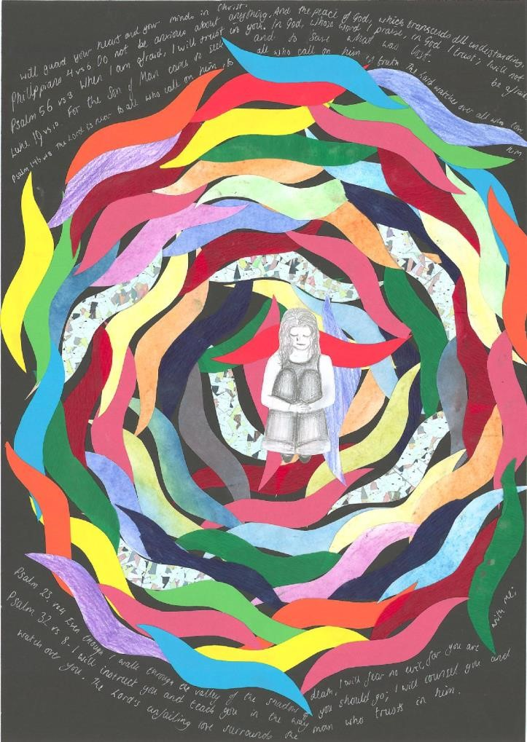

RE aims to enable all pupils, religious, agnostic or atheist,
to explore spirituality for the
mselves, as 15 year old Becky
does in this image of spiritual life

Progress steps in RE for 5-14s
8 steps in relation to the three elements of the RE aim.
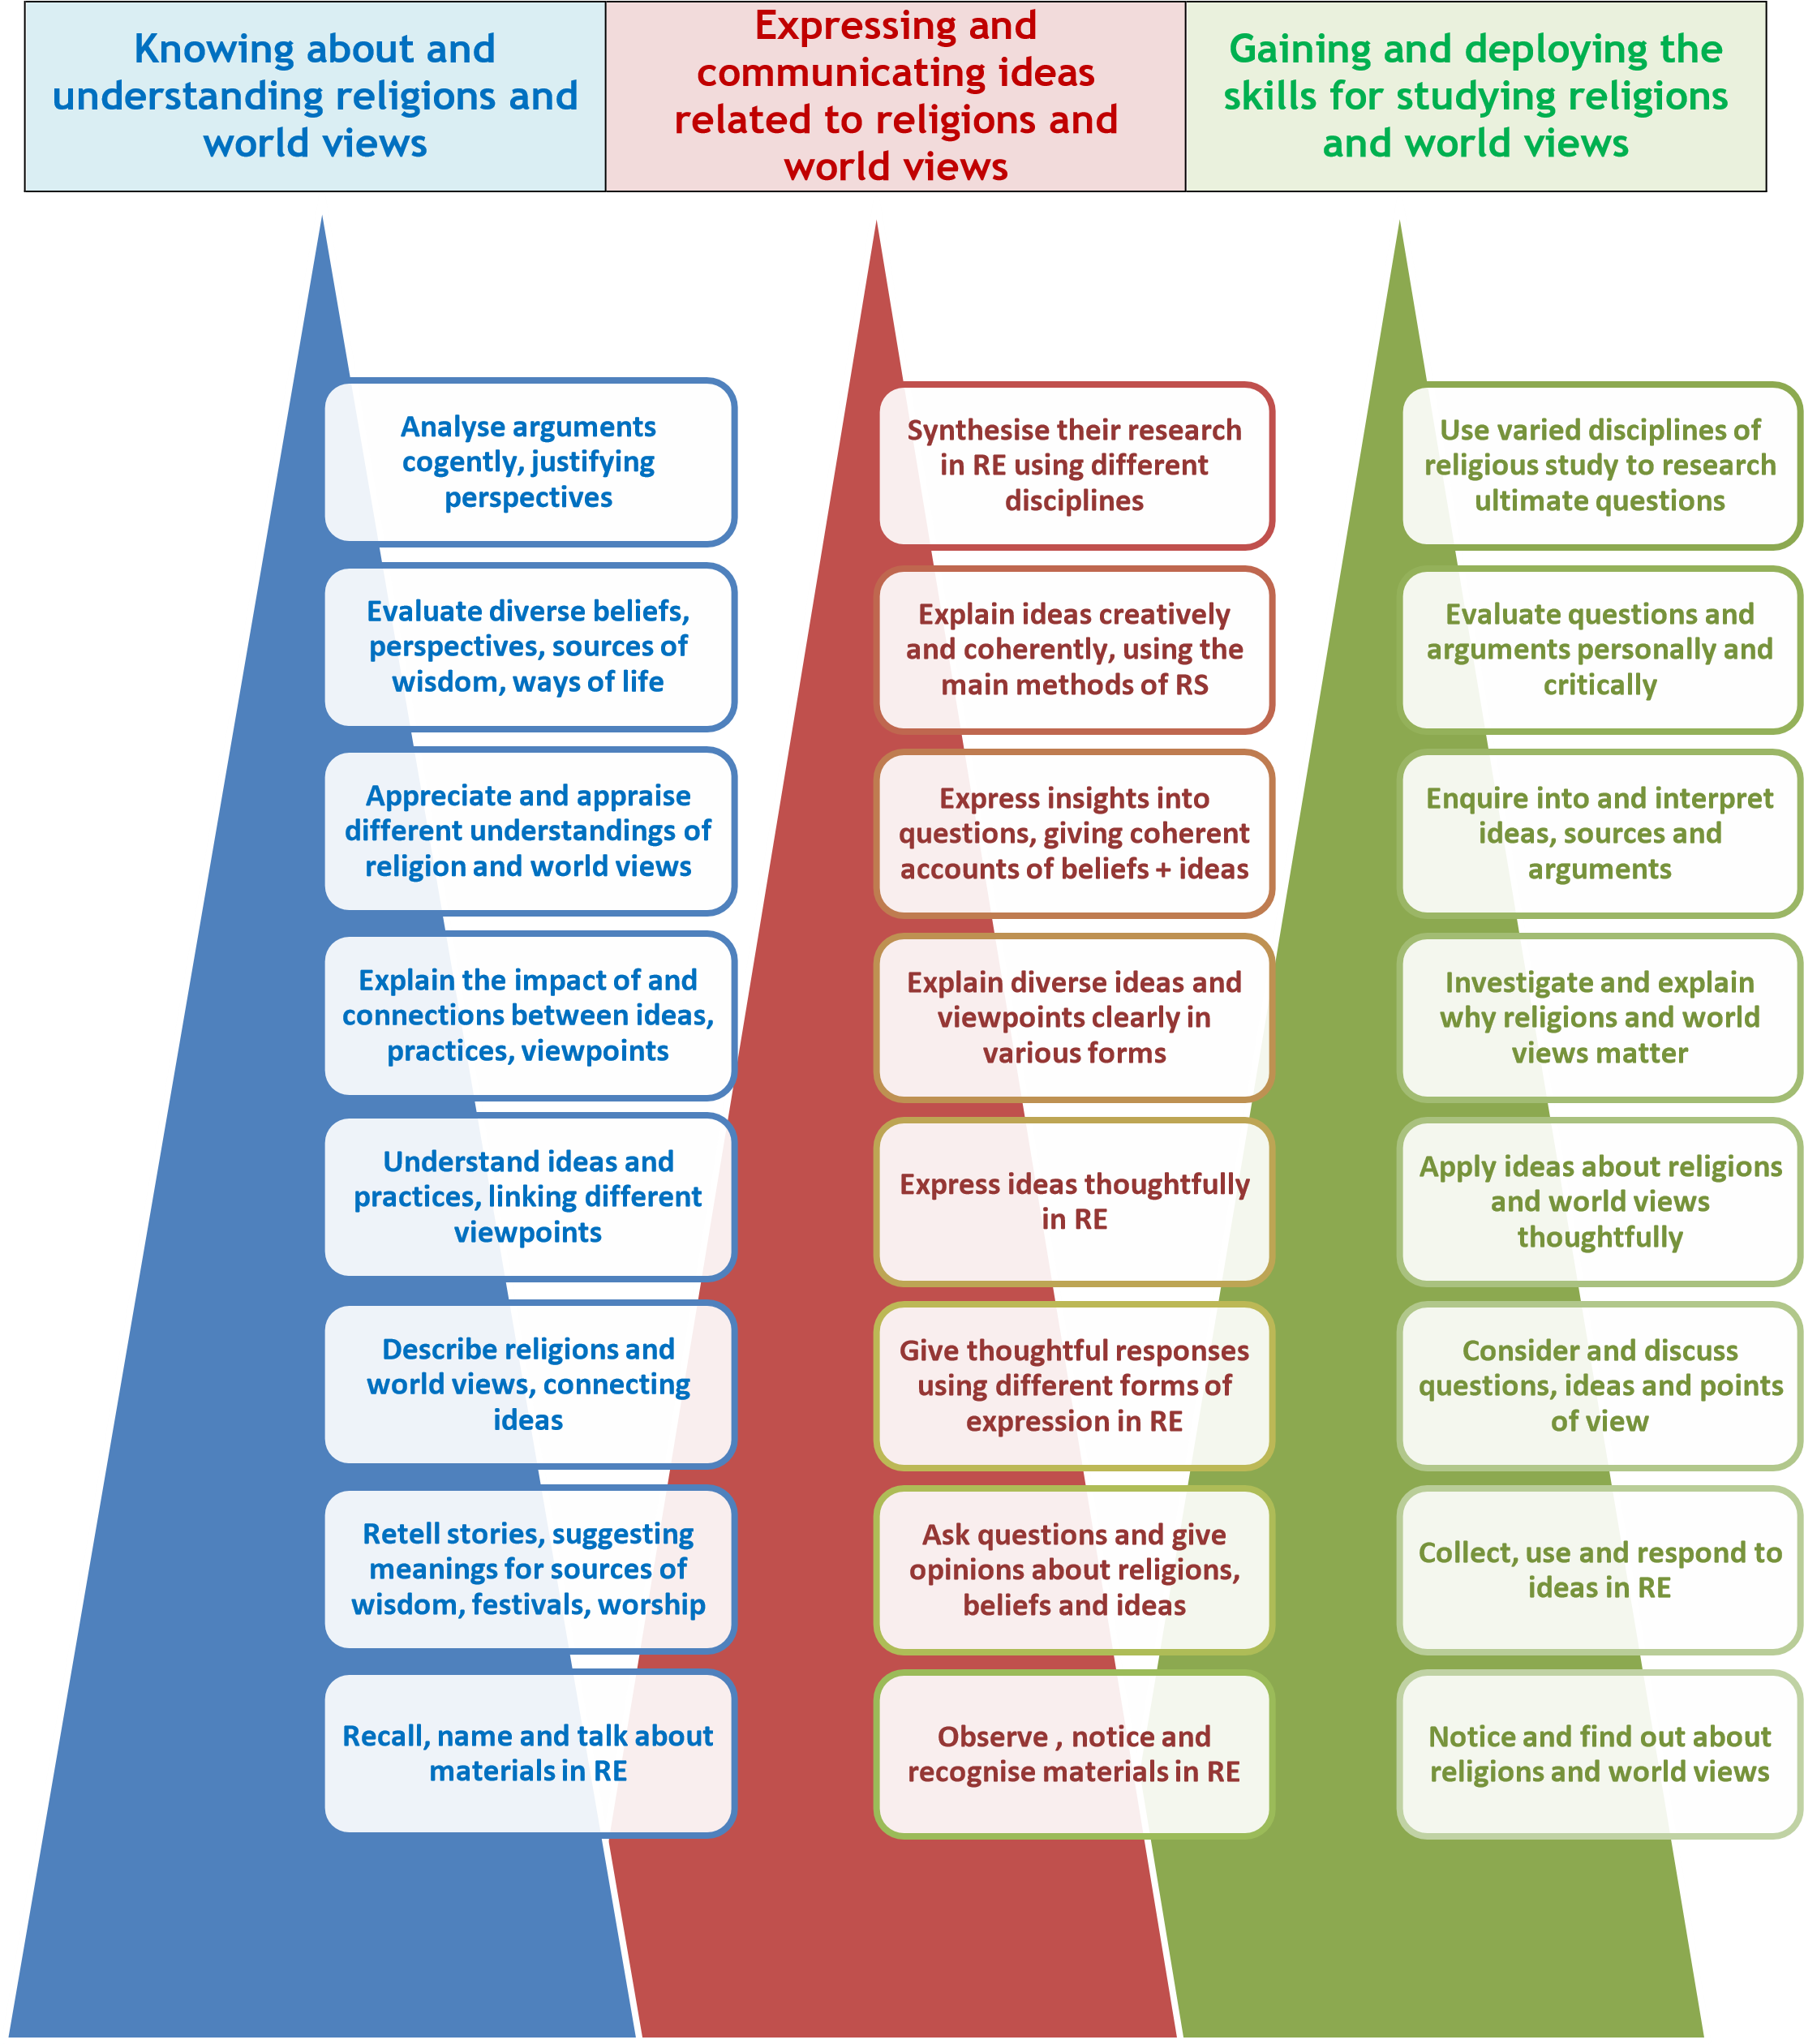
- How can teachers and schools monitor and measure whether pupils are on track to meet end of key stage expectations and outcomes?
  - Some schools and subject leaders will want to develop current practice arising from the 8 level scales in use in RE, showing smaller steps towards to the outcomes of the syllabus, the achievements expected of pupils at the end of a key stage;
  - Other schools and subject leaders will find the pyramids illustrating progression above are a useful guide to thinking and planning comprehensively and developing pupils’ skills across the range of RE’s aims.
  - It is important that RE assessment addresses all that pupils gain from the subject appropriately. The skills of investigation or reflection on meaning are as important as the acquisition of knowledge;
  - As the new National Curriculum structures are put into practice, it is expected that further work on this area will be needed for RE, to support teachers of RE in many settings. One thing that will make such work valuable will be a close connection to emerging structures for assessing other subjects, such as Science, History or
Geography. Sheffield SACRE is committed to supporting teachers further in this area.

- How can teachers of RE pinpoint aspects of the curriculum where pupils may be falling behind, and also recognise exceptional performance?
  - Assessment for learning: subject leaders and teachers should establish good practice in assessment for learning for each age group, in ways that enable pupils with SEND and gifted and talented pupils to show their achievements clearly, so that next steps in learning can be planned appropriately for every child. Collaborative approaches between schools will be helpful here;
  - Differentiation: subject leaders and teachers should plan RE in the light of the fact that some pupils need to work below or above the outcomes expected for their age group in order to make the best progress possible in the subject.

- How can the descriptions of expectations for the end of each key stage in RE support teachers’ planning for all pupils?
  - Using the learning outcomes: subject leaders and teachers in RE should plan their approach to the whole key stage with the learning outcomes for the end of the key stage in clear view. The syllabus has paid close attention to end of key stage outcomes in particular to make this possible;
  - Setting high expectations early in the key stage: in terms of the matters, skills and processes of RE work which challenges pupils to aim for the end of key stage outcomes early in their programmes of study is most likely to enable all pupils to reach the highest possible standards;
  - Planning progression step by step: Clear planning by subject leaders and teachers needs to deepen knowledge and understanding, to enable expression and communication and to recognise the skills pupils gain and deploy in studying religions and world views. Good programs of assessment will describe clear steps that lead towards to the end of key stage achievements and outcomes.

- How can expectations for RE be used to report strengths and weaknesses of pupils progress to parents, and to other schools and teachers upon transfer?
  - As with all subjects of the curriculum, parents are entitled to expect an annual report which clearly describes the progress and achievement of each child in relation to the RE program of study;
  - Good RE reporting is individual, positive, criterion referenced, accurate and diagnostic.

Analyse arguments  cogently, justifying  perspectives  Evaluate diverse  beliefs, perspectives,  sources of wisdom,  ways of life  Appreciate and  appraise different  understandings of  religion and world  views  Explain the impact of  and connections  between ideas,  practices, viewpoints  Understand ideas and  practices, linking  different viewpoints  Describe religions and  world views,  connecting ideas  Retell stories,  suggesting meanings  for sources of wisdom,  for festivals and for  acts of worship  Recall, name and talk  about materials in RE  Knowing about  and understanding  religions and  world views | Examples: Knowing and understanding  These examples of the knowledge and understanding pupils gain in RE need to be read in the light of the RE requirements for each key stage, and enable the planned progression in learning that pupils need.  8. Pupils use varied methods from sociology of religion to analyse the ways Christian, Muslim and Sikh population patterns and community life are changing in 21st century Sheffield and in Britain. They justify their perspectives on whether and how a plural society can be built peacefully  7. Pupils weigh up debates and arguments between agnostics, Christians and Muslims about diverse ideas of God, using philosophical methods. They evaluate the arguments of others in relation to their own ideas and viewpoints, using skills of personal and critical evaluation  6. Pupils argue for their answer to the question ‘would an omnipresent God need special places for people to worship?’ They examine the architecture of mosques, cathedrals and mandirs in the UK today, developing their appreciation and appraisal of forms and functions of varied places of worship  5. Pupils explain the impact that religious and/or spiritual experiences have had on some people from ‘eyewitness’ accounts. They give their reasons for accepting or rejecting some explanations of these events including psychological and theological explanations  4. Pupils consider some different possible meanings for two parables of Jesus, considering what the parables mean to Christians today. They rank the possible interpretations, giving a reason why they consider one is a better interpretation than another.  3. Pupils select their favorite 2 or 3 ‘wise sayings’ from 10 examples drawn from different sources (Bible, Qur’an, Torah, Dhammapada), and illustrate these sayings. They describe what each religion teaches in relation to the sayings. They describe connections between the sayings they have chosen.  2. Pupils enact two stories. Examples could be parts of the story of Holy Week and Easter, and parts of the Divali story. They discuss the ideas and characters, and suggest what the stories mean.  1. Pupils discover how Muslims wash, bow and pray in a daily pattern, for example, learning the word wudu / wuzu. They name the religion, and the word for washing Muslims use and talk about what happens and what it might mean.

Expressing and ^{6.}
communicating ideas relating to religions and world views
Synthesise their research in
RE using different disciplines
Explain ideas creatively and coherently, using the main methods of religious study
Express insights into questions, giving coherent accounts of beliefs + ideas
Explain diverse ideas and viewpoints clearly in various forms
Express ideas thoughtfully in RE
Give thoughtful responses using different forms of expression in RE
Ask questions and give opinions about religions, beliefs and ideas
Observe , notice and recognise materials in RE

Examples: Expressing and communicatingSheffield SACRE Religious Education Syllabus 2014
These examples of the communication and expression pupils learn in RE need to be read in the light of the RE requirements for each key stage, and enable the planned progression in learning that pupils need.
8. Pupils consider the questions: Is Buddhism a religion? In what ways is Humanism like a religion? They bring together their research into the two questions, evaluating arguments about the nature of religions and world views critically. They answer for themselves: why are you religious, or not religious?
7. Pupils give coherent and thoughtful explanations of the thought and poetry of Primo Levi and Dietrich Bonhoeffer, religious thinkers persecuted under Nazism. They use historical and theological methods to evaluate the question: is it possible to believe in God after the holocaust?
6. Pupils express insights of their own in comparing of the influence of Aung San Suu Kyi and of Rev Dr Martin Luther King. They give coherent accounts of the impact of ideas such as non-violence, pacifism and spiritual strength. They make coherent connections between Buddhist and Christian ideas, beliefs and practice and the influences they examine.
5. Pupils are given 8 quotations, four of which claim religion is a force for good, and four which say it does more damage than good. They use the ideas to explain their viewpoint about the question ‘Is religion a force for good or not?’
4. Pupils express thoughtful ideas about the 5 Pillars of Islam, applying the general concepts of devotion to God, service of other people and self discipline to Muslim practice. They give a thoughtful idea of their own about the value of the practices.
3. Pupils discuss three religious artworks from three different centuries, considering what inspired these artists do great work that is religious. They respond by choosing examples of religious art that they find inspiring. They create expressions of their own ideas. 2. Pupils take part in a music session using songs about peace from different religions. They ask questions and say what they like about the songs’ words, and what is important about peace to them.

1. Pupils watch a video of some interesting festivities at Divali and Easter, and ask ‘Who, What, When, How, Why?’ questions about what they have seen.

Use varied disciplines of  religious study to  research ultimate  questions  Evaluate questions and  arguments personally  and critically  Enquire into and  interpret ideas, sources  and arguments  Investigate and explain  why religions and world  views matter  Apply ideas about  religions and world  views thoughtfully  Consider and discuss  questions, ideas and  points of view  Collect, use and respond  to ideas in RE  Notice and find out  about religions and  world views  Gaining and  deploying the skills  needed to enquire  into religions and  worldviews. | Examples: gaining and deploying skills  These examples of the skills of religious study that pupils gain and deploy in RE need to be read in the light of the RE requirements for each key stage, and enable the planned progression in learning that pupils need.  8. Pupils use ideas and methods from theology, philosophy and psychology to research varied answers to questions about God, discovering and expressing arguments from different viewpoints comprehensively.  7. Pupils evaluate research that finds religious people are happier than non-religious people, asking: can this be proved? What evidence is there? What explanations are there? Does this finding offer evidence in favour of religion, or does it merely imply that illusions can be comforting?  6. Pupils plan an enquiry into identity: why do millions of people identify themselves as atheists, Christians or Muslims in Britain today? They communicate their interpretations of the world views of others accurately.  5. Pupils investigate questions about life after death, explaining varied answers, using concepts like consciousness, soul, Nirvana or Paradise. They explain the impact of varied views about life after death on life today, expressing ideas about destiny reasonably, creatively and thoughtfully.  4. Pupils hear the stories of the enlightenment of the Buddha, of the giving of the Qur’an in Islam and of the birth of Jesus in Christianity. They consider what members of the religion believe these stories show. They learn the word ‘revelation’, and apply the idea to the stories. They discuss: what does it mean to believe in revelation?  3. Pupils consider and discuss examples of what key leaders from stories in two different faiths have done to make peace. They raise questions about peace making, giving thoughtful ideas of their own on the question: would you like to be a peace maker?  2. Pupils collect examples of living together happily both from school life and from religious stories. They offer ideas of their own to be included in a ‘Recipe for living together happily.’  1. Pupils show curiosity about what Muslims, or Jews or Christians do each day or each week. They notice some details which interest them, and find out more.

Additional Support and Guidance
As well as this statutory syllabus, SACRE have provided a wide range of guidance and support materials for the teacher of RE. These include key items to help teachers:
- Launch the syllabus with our ‘ready to use’ presentation. A PowerPoint presentation to use with staff and governors in every school to introduce the new syllabus and to provide an inspiring vision of the place and value of RE in every child’s education.
- Put the RE poster up in classrooms and staffrooms. The Sheffield SACRE RE Poster (ready to print and available to adapt).
- Use the exemplar medium term plans. Twelve ready to use medium term exemplar plans for pupils across the age range 4-14.
- Write more plans to the standard template. A blank template of a curriculum investigation plan for teachers to use in writing their own plans for RE.
- Improve confidence and subject knowledge with our Beginners’ Guides. Beginners’ Guides to the six religions in the syllabus and to Humanism – for the teacher to use as a ‘first base’ reference point when they teach a religion with which they are less familiar
- Use the pyramids to describe RE outcomes clearly: a PDF of the three pyramids for use as a classroom or staffroom poster.

Acknowledgements

Sheffield SACRE would like to thank all those involved in developing this RE syllabus for their commitment to and involvement in the making of this RE Syllabus: Committee A

Kate Arrowsmith; Musa Bako; Paul Bellingham; Barbara Bergman; Abdool Gooljar; Mary Hearnshaw; Greg Nettleship; Dr Vitel Patel; Ray Soulsby; Mark Wells
Committee B
John Bentley; Margaret Langrish; Huw Thomas

Committee C
Louise Cline; Alison Dallman; Sue Hopkinson; Judith Pyatt; Helen Sheehan; Lisa Vickerage

Committee D
Antony Hughes; Councillor Martin Lawton; Andrew McDowell

The Working Group
Huda Ahmed; Lat Blaylock; Alison Dallman; Sue Hopkinson; Siobhan Hoys; Paul MooreBridger; Helen Sheehan; Joanne Smith; Danielle Throssell; Joy Tsai; Kit Thorne; Lisa Vickerage

Other partners
Mike Granville; Richard Lamb; Jayne Ludlam; Zanib Mushtaq; Hugh Pyper; Kit Thorne

Enquiring Minds & Open Hearts:
Religious Education for all

The Agreed Syllabus for RE in Sheffield
2014-2019

Breadth: in line with the law and the statement about breadth of learning on page 6 above, best practice will enable pupils to learn from Christianity and at least two other examples of a religion or world view through Key Stage Two. Schools are advised to select two religions from Islam, Hinduism, Judaism and Buddhism.
Breadth: in line with the law and the statement about breadth of learning on page 6 above, best practice will enable pupils to learn from Christianity and at least three other examples of a religion or world view through Key Stage Three.
The RE Program of Study usually refers to ‘religions and worldviews’ to describe the field of enquiry. Here, however, ‘religion’ in the singular specifies the aim: to consider and engage with the nature of religion broadly, not merely with individual examples of religions or world views.
All state funded schools must provide RE for all students on school rolls, including all those in 14-19 education. It is important that teaching enables progression from the end of Key Stage 3, in varied ways that meet the learning needs of all students. All students can reasonably expect their learning will be accredited. These modes of accreditation include nationally accredited courses in RE such as GCSE and A level RS, and a wide range of enrichment courses and opportunities. Good practice examples include many faith schools and some other school types where all students take GCSE RS courses at 16.
An elaborated version of these summary skills pyramids, including more detail and examples, follows in the syllabus (page 36ff). A ‘simplest’ version of the pyramids, using one skill for each of the 8 steps in progression, is included as an appendix to the syllabus.

